**Home Page**

**Department of Artificial Intelligence & Data Science**

**Welcome Message**

The Department of Artificial Intelligence & Data Science is committed to developing technically sound, ethically strong, and industry-ready engineers who can shape the future with intelligent systems and smart technologies.

**Department of Artificial Intelligence and Data Science shall,**

* To deliver a high-quality education by fostering a transformative environment where students are encouraged to thrive in their academic endeavors, to prepare students to obtain application knowledge in the burgeoning industry and to become deeply knowledgeable in artificial intelligence and data science.
* To give students the opportunity to fully develop their own skills and realize their potential while being taught by experienced, skilled, and committed staff, to uphold a degree of competence and standards in all the courses they take to become experts in data science and artificial intelligence.
* To improve and equip students with the skills they need to favorably impact society through the use of this cutting-edge technology.

**Program Overview**

The B.E. program blends foundational engineering education with cutting-edge topics in AI and data science. The course structure equips students with:

* Programming expertise
* Mathematical rigor
* Ability to build scalable AI-driven applications

**Key Technologies & Skills**

Students gain proficiency in:

* Deep learning
* Data mining
* Cloud platforms
* Robotics
* Computer vision
* Intelligent automation
* Machine learning
* Big data analytics
* Data modeling
* Statistical analysis
* Knowledge discovery
* Visualization

**Learning Approach**

* Practical labs
* Mini-projects
* Internships
* Solid application-oriented learning experience
* Design-based learning
* Cutting-edge pedagogies

**Innovation & Research**

The department actively promotes innovation through:

* Hackathons
* Research clubs
* Startup initiatives
* Interdisciplinary solutions leveraging AI
* Focus on societal, industrial, and environmental challenges

**Graduate Preparedness**

Strong focus on:

* Lifelong learning
* Collaboration
* Professional ethics
* Roles in top tech firms
* Research institutions
* Entrepreneurship in AI-driven digital economy

**Head of Department**

**Dr. Manjunath T. K**

* **Position**: Professor & Head
* **Qualifications**: B.E, M.Tech, Ph.D (Post Doc.)
* **Department Established**: 2020/2021

**HOD's Message**

The department was established with the purpose of educating students and carrying out research in the domains of Artificial Intelligence & Data Science. Highly competent professors with rich experience from renowned universities in India and abroad make up the department.

**Department Goals**:

* Provide world-class infrastructure and technologies
* Extensive hands-on exposure through industry connect programmes
* Prepare students to be leaders in AI and DS
* Foster academic achievement, industrial exposure, and exceptional career possibilities

**Faculty Development**:

* Motivates staff to pursue higher studies
* Encourages attendance at conferences and workshops
* Promotes publishing papers in national/international conferences/journals

**Department Profile**

**About AI & DS**

Artificial Intelligence (AI) and Data Science (DS) is a new, exponentially growing field consisting of a set of tools and techniques used to extract useful information from data.

**B.E. in AI & DS Program**

An undergraduate programme with advanced learning solutions imparting knowledge of:

* Artificial intelligence
* Data science
* Machine learning
* Deep learning

**Main Goals**

* Program computers to use example data or experience to solve given problems
* Build intelligent machines, software, or applications
* Combine machine learning, analytics and visualization technologies

**Course Focus**

* Intelligent data analysis for real-world applications
* Core technologies: AI, data mining, data modeling
* Intensive inputs in machine learning and big data analytics
* Cross-disciplinary skills: statistics, computer science, machine learning, logic

**Career Opportunities**

Students may have career opportunities in:

* Healthcare
* Business
* eCommerce
* Social networking companies
* Climatology
* Biotechnology
* Genetics
* Other important areas

**Program Focus**

Equip students with:

* Statistical skills
* Mathematical reasoning
* Machine learning
* Knowledge discovery
* Visualization skills

**Highlights of Department**

1. Design-based learning and cutting-edge pedagogies
2. Well-researched and carefully crafted curricula
3. Facilities for modern research and infrastructure
4. Personal growth and skill development
5. Exciting Career Opportunities, Placements, and Internships
6. Annual AI Prototype Exhibition/Programs
7. Resources for entrepreneurship, innovation, and incubation
8. The use of real-world applications
9. Freedom in specialized streams

**Advantages of AI & DS Graduates**

1. Specialized branch with huge scope of growth and ample opportunities
2. KSSEM has expert faculty in the field of AI & DS
3. Great potential for startups apart from jobs
4. Industry mentors guide students to develop startup culture
5. **Job packages range from 4 LPA to 27 LPA**
6. Design/Implementation-based learning prepares students for high-end jobs
7. Encourages innovation and entrepreneurship through applied learning
8. Well-structured curriculum builds strong domain knowledge
9. Hands-on projects help solve real-world problems
10. Advanced tools exposure prepares students for future roles
11. Credit-based system encourages global certifications

**Academic Programs Offered**

**UG Program**

* **Degree**: Bachelor of Engineering (B.E.) in Artificial Intelligence and Data Science (AI & DS)
* **Approved Intake**: 120 students
* **Lateral Entry**: 20% from 2nd year

**News & Achievements**

**1. Vandana C - 5th Rank VTU**

Congratulations to our AI & DS department and student Vandana C for securing 5th rank in VTU - a proud moment of excellence and achievement!

**2. FDP on Advanced Machine Learning Using Python**

* **Duration**: 5 days
* **Dates**: June 10, 2025 to June 14, 2025
* **Purpose**: Bridge the gap between Academia and Industry
* **Organized by**: Department of AI&DS

**3. SAP Hackfest 2025 Regional Round**

**Objective**: Empower young innovators to solve real-world problems using:

* Artificial Intelligence
* Data Analytics
* Design Thinking
* Digital Transformation
* Aligned with SAP's mission of fostering a smarter and more sustainable future

**4. Skills for Future Advance Engineering Course Orientation Program**

**Focus**:

* Equips students with emerging technical skills
* Innovation mindset
* Adaptability for Industry 4.0
* Emphasizes interdisciplinary learning
* Problem-solving
* Readiness for future engineering challenges

**Upcoming Events**

**1. AI Careers for Women**

* **Organized by**: Department of AI & DS in collaboration with Microsoft and SAP
* **Description**: Prestigious national initiative designed to equip women with industry-relevant skills in Artificial Intelligence

**2. Industrial Visit for 5th Sem AI&DS**

* **Venue**: VOIS Office, Bangalore
* **Address**: Vodafone India Services Pvt. Ltd., BDC1, 10th floor, Tower A & B, Global Technology Park, Marathalli, Bangalore
* **Date**: October 27 (Monday)

**3. Django meets AI Full Stack ML Bootcamp**

* **Topic**: Workshop on "Django meets AI full stack ML Bootcamp"
* **Month**: September
* **Target**: 7th sem students

**Department Sections/Resources**

The department offers the following sections:

* Profile
* PO, PEO & PSO (Program Outcomes, Program Educational Objectives & Program Specific Outcomes)
* Professional Bodies
* Teaching and Learning
* Time Table
* Syllabus
* News Letter
* Faculty
* FDP (Faculty Development Programs)
* Achievers
* Infrastructure/Facilities
* Gallery
* Departmental Library
* Placement Details
* Higher Education
* Student Club
* Internships & Projects
* Industrial Visit
* Events
* E-Resources
* Project Exhibition
* MOUs Signed
* Social Activities
* Other Details
* Video Testimonials

**Placements**

**Placements for Artificial Intelligence & Data Science at KSSEM**

* Alumni thrive in renowned companies
* Driving innovation and excellence
* Job packages: 4 LPA to 27 LPA
* **Program Outcomes (POs)**
* **PO-1:**  
  *Engineering Knowledge:* Ability to use knowledge of science, arithmetic, engineering basics, and a particular technical speciality to solve complicated engineering issues.
* **PO-2:**  
  *Problem Analysis:* Ability to recognize, formulate, conduct literature reviews, and use first principles of mathematics, natural sciences, and engineering sciences to understand difficult engineering issues in mechanical engineering.
* **PO-3:**  
  *Design/Development of solutions:* An ability to design solutions for complex engineering problems and system component or processes that meet the specified needs considering public health & safety and cultural, societal & environment.
* **PO-4:**  
  *Conduct Investigations of Complex problems:* An ability to use research-based knowledge and research methods including design of experiments, analysis and interpretation of data and synthesis of the information to obtain solutions to engineering problems.
* **PO-5:**  
  *Modern Tool Usage:* Ability to create, select and apply appropriate techniques, resources and modern engineering activities, with an understanding of the limitations.
* **PO-6:**  
  *The Engineer and Society:* Ability to apply reasoning informed by the contextual knowledge to assess societal, health, safety, legal and cultural issues and the consequent responsibilities relevant to the professional engineering practice.
* **PO-7:**  
  *Environment and Sustainability:* Ability to demonstrate the knowledge of engineering solutions, contemporary issues understanding their impacts on societal and environmental contexts, leading towards sustainable development.
* **PO-8:**  
  *Ethics:* An ability to apply ethical principles and commit to professional ethics and responsibilities and norms of engineering practice.
* **PO-9:**  
  *Individual and Team Work:* An ability to function effectively as an individual, and as a member or leader in diverse teams and in multi-disciplinary settings.
* **PO-10:**  
  *Communication:* Ability to communicate effectively oral, written reports and graphical forms on complex engineering activities.
* **PO-11:**  
  *Project Management and Finance:* Ability to demonstrate knowledge and understanding of the engineering and management principles and apply those one's own work, as a member and leader in team, to manage projects and in multi-disciplinary environments.
* **PO-12:**  
  *Life-Long Learning:* An ability to recognize the need for and having the preparation and ability to engage independent and life-long learning in broadest context of technological change.  
  **Teaching And Learning**
* The faculty of aids department attends various MOOCS and training programs on advanced topics, update their knowledge and skills, and gives additional inputs in the classes. Further, the faculty conducts various innovative teaching and learning activities inside and outside the classrooms to engage the students effectively and efficiently. The teaching and learning activities conducted by the faculty for the improvement of student learning includes:
* Teaching with working models, simulations and animated videos
* Assignments which include Miniprojects and Case studies
* Conduction of online and classroom quizzes, surprise class tests, open book assignments, group discussions, seminars etc.
* Usage of ICT, Pupilpod and Google classrooms for posting assignments and lecture materials
* Usage of Google forms and Kahoot for online interaction, assessment and evaluation
* The instructional materials and pedagogical activities are uploaded in Google drive and the associated links are made available on institutional website for student and faculty access.
* **Instructional Materials**
* Instructional Materials are made available for public access.
* **Pedagogical Activities**
* Pedagogy is the method and practice of teaching an academic subject or theoretical concept. Pedagogical skills involves being able to convey knowledge and skills in ways that students can understand, remember and apply. Pedagogies involve a range of techniques, including whole-class and structured group work, guided learning and individual activity. Pedagogies focus on developing higher order thinking.
* Department CCM activities were conducted on 29th December 2023 [[view here]](https://https/drive.google.com/file/d/1AJyBSK4lPWVaY-ZmdjMEMiSwJFW_JxRA/view?usp=drive_link)
* **Pedagogy Review Form**
* The Peer review forms associated with pedagogical activities are made available for public access, peer review, critique and further development.
* **Lab Manuals**
* AI_LabManual(BAI402) [[view here]](https://drive.google.com/file/d/18K8V7swXVfDmAcjz8OddwN4jazuCdatd/view?usp=sharing)
* DSandApplication_LabManual(21AD62) [[view here]](https://drive.google.com/file/d/1Ec3ksZc0zIxTGdP5HSLdBwIaK2oHTHv1/view?usp=drive_link)
* MongoDB_LabManual(BDSL456B) [[view here]](https://drive.google.com/file/d/1_QoogMPylYUiKiOUDjIpc8JsmoflKlEB/view?usp=drive_link)
* PythonforDS_LabManual(BDS306B) [[view here]](https://drive.google.com/file/d/138P8hwHrh7jDanugFKVNjHSdzNzrHyyC/view?usp=drive_link)
* DS_LabManual(BCSL305) [[view here]](https://drive.google.com/file/d/1Go8t9th4IV4zBmvyFRrii_oC-ja1U1iF/view?usp=drive_link)
* OS_LabManual(BCS303) [[view here]](https://drive.google.com/file/d/1Rn_7NBBwwsK_xFWr1oYEcrTVHxHqj4qB/view?usp=drive_link)
* DBMS Lab Manual(BCS404) [[view here]](https://drive.google.com/file/d/1MOJU58wjBeOfimkqCCfV704UkspLPPRo/view?usp=sharing)
* DDCO Lab Manual(BCS302) [[view here]](https://drive.google.com/file/d/1raKiM5k3485Tn8eowdEBkAm3xRKNUpZy/view?usp=sharing)
* DBMS Lab Manual(BCS403) [[view here]](https://drive.google.com/file/d/1-xMHQcei37wOABtl88Kz1srLCE18036Z/view?usp=drive_link)
* GIT_Lab Manual(BCS558C) [[view here]](https://drive.google.com/file/d/1PS6aLCVps7ZOk9hNw1MW1sPumVJqWDhj/view?usp=drive_link)

[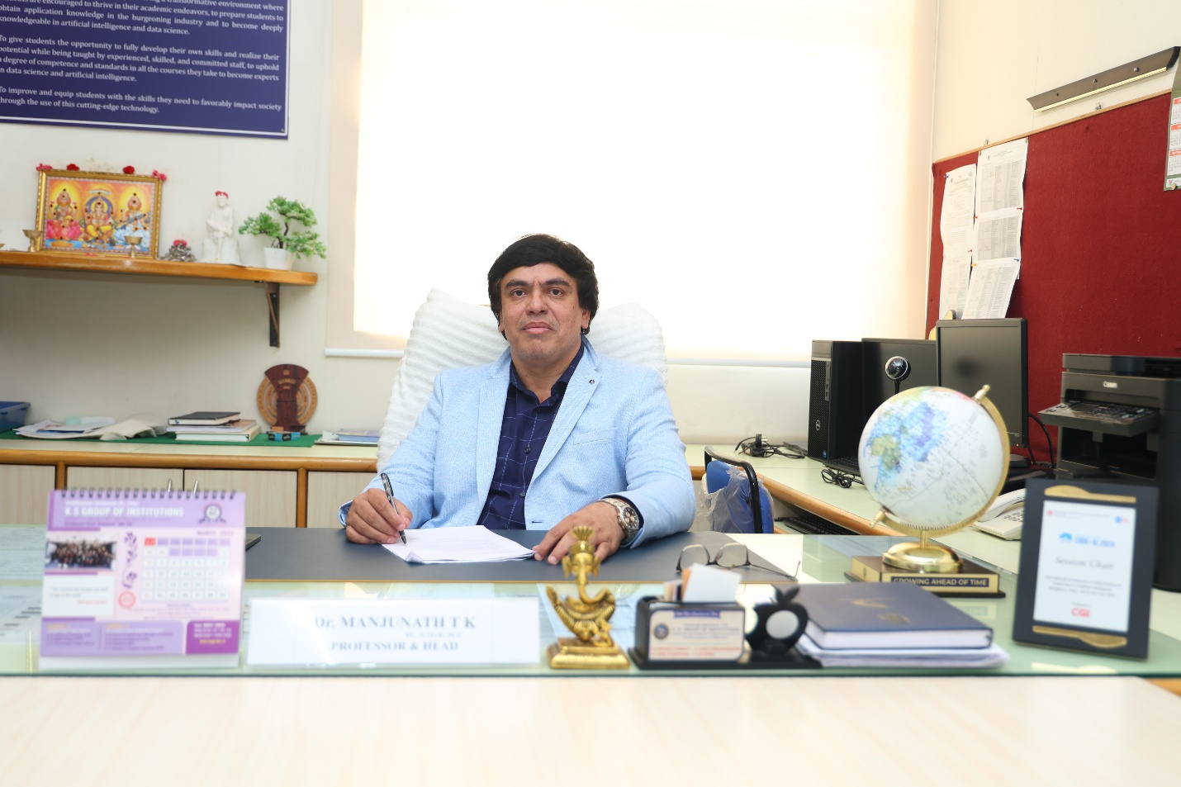](https://kssem.edu.in/images/2c9f8d418782cedb018793539865000f_image.JPG)

**Dr. Manjunath T K**

**Professor and Head**

BE, MTech, PhD(Post.Doc)

[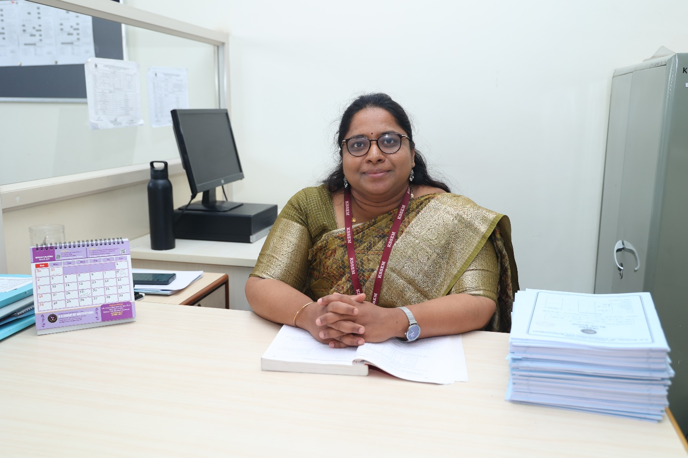](https://kssem.edu.in/images/2c9f8d4185eb4be40185f78eb44a0017_image.JPG)

**Dr. Pavana H**

**Assistant Professor**

BE, MTech,PhD

[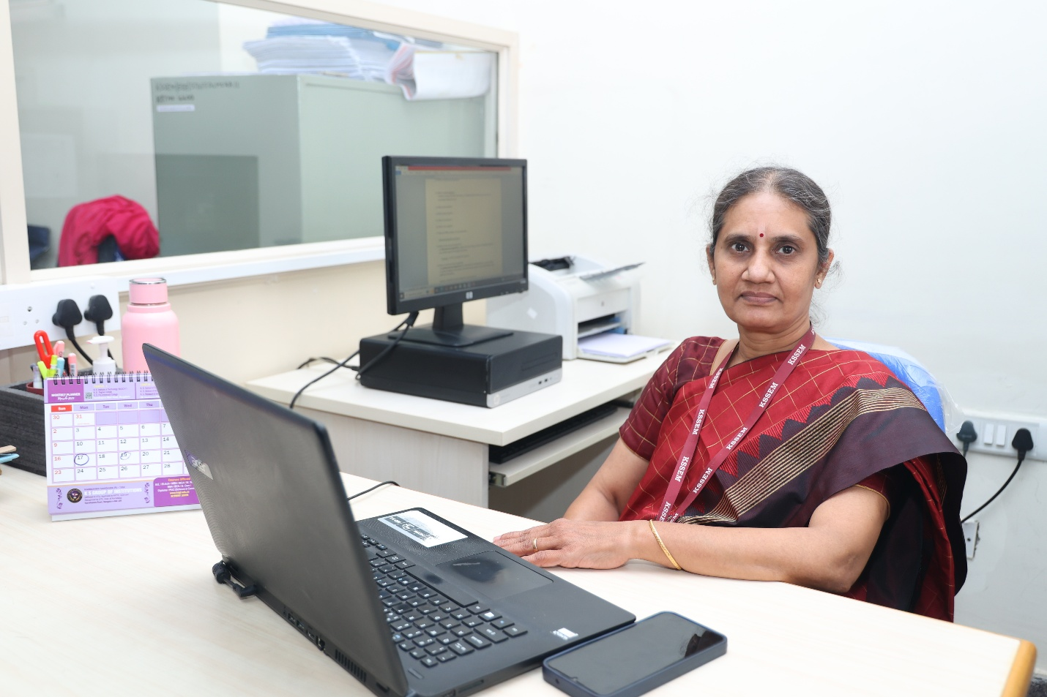](https://kssem.edu.in/images/2c9f8d4185eb4be40186017513870028_image.JPG)

**Mrs. P S Geetha**

**Assistant Professor**

B.Sc, MCA

[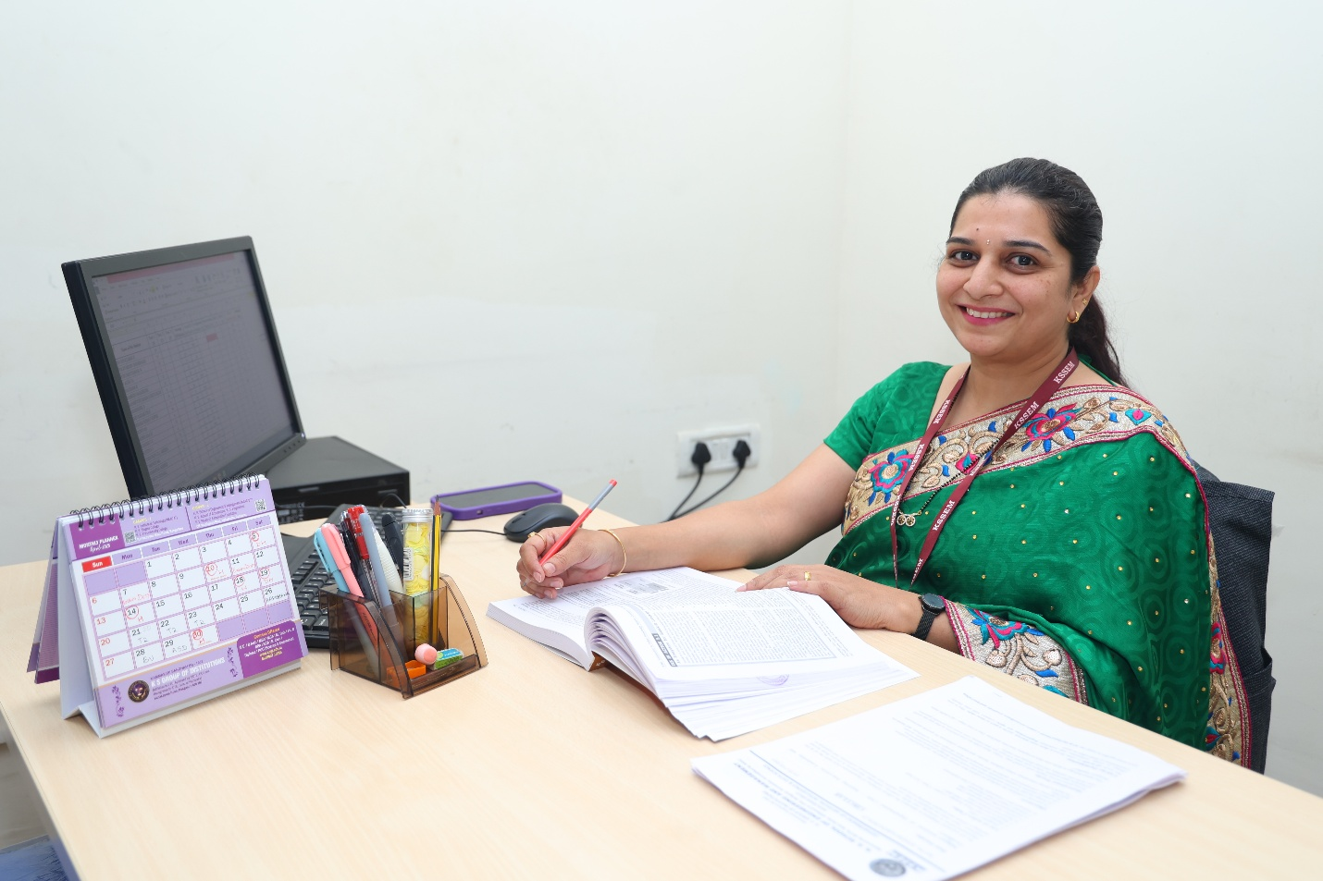](https://kssem.edu.in/images/2c9f858d953bb0f301953c92f6900004_image.JPG)

**Mrs. Sneha Karamadi**

**Assistant Professor**

B.E,M.Tech

[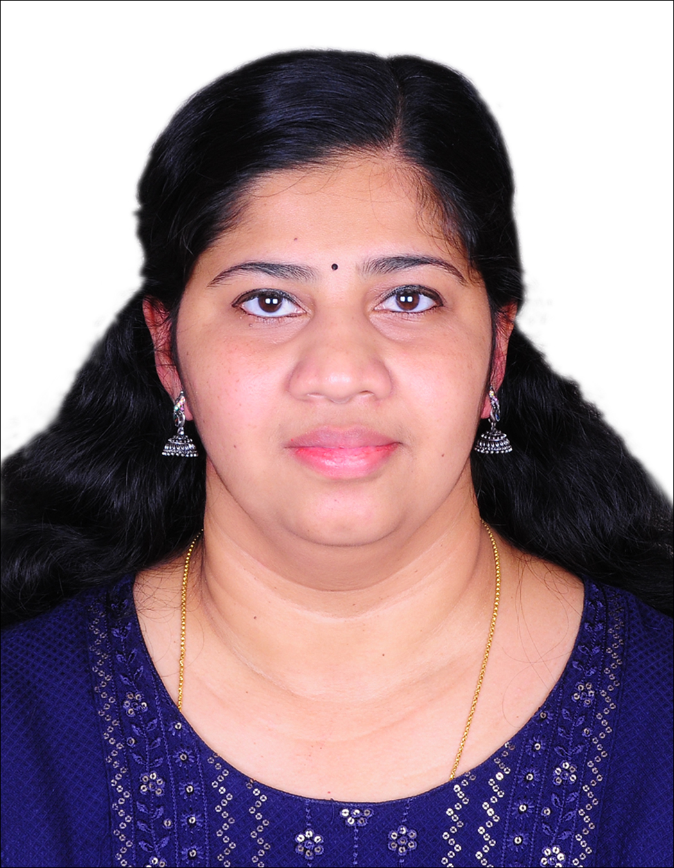](https://kssem.edu.in/images/1756181570879_image.jpg)

**Mrs. Sruthy V Nair**

**Assistant professor**

M.E (computer Science Engineering)

[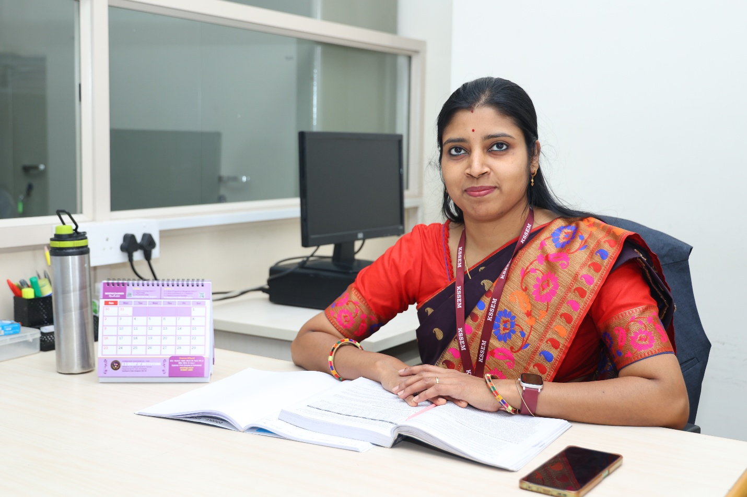](https://kssem.edu.in/images/2c9f8d4185eb4be40185f78fb8d50018_image.JPG)

**Mrs. Madhusmita Mishra**

**Assistant Professor**

BTech, MTech

[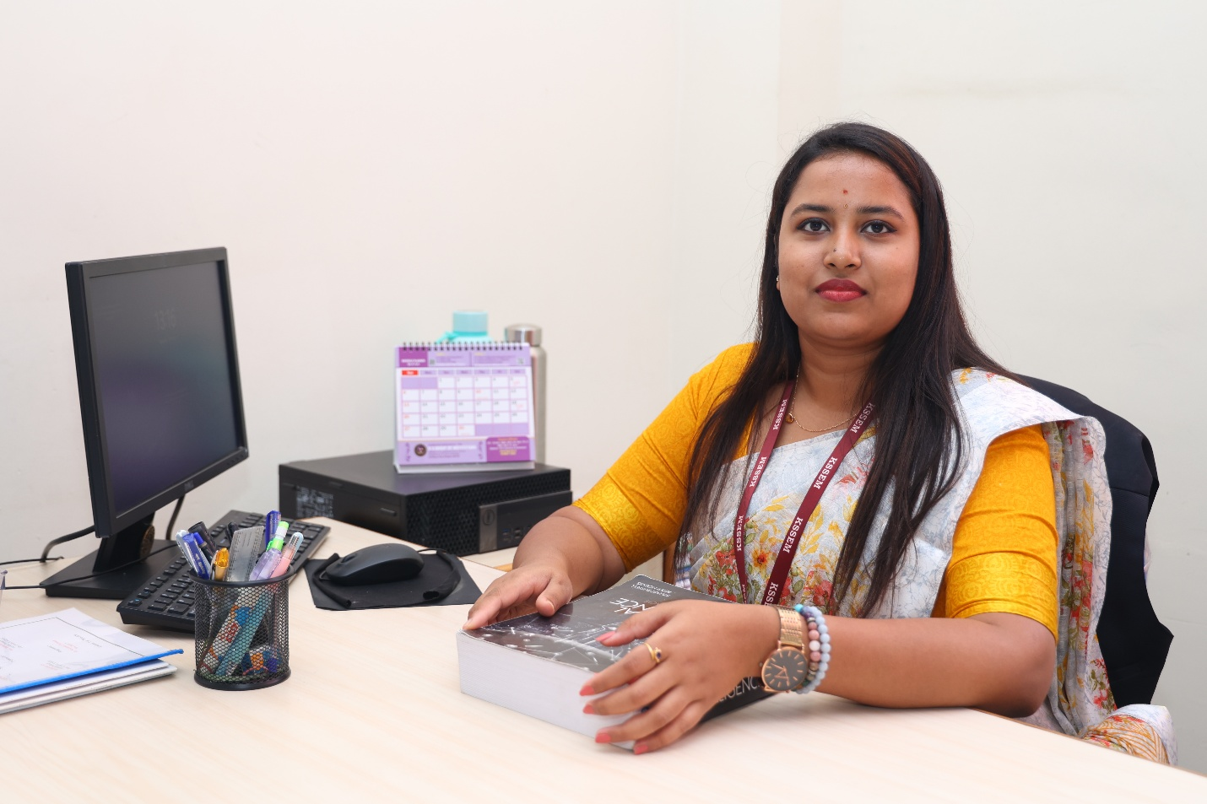](https://kssem.edu.in/images/2c9f8d418b13f419018b1de050170014_image.JPG)

**Ms. Harshitha H S**

**Assistant Professor**

BE, MTech

[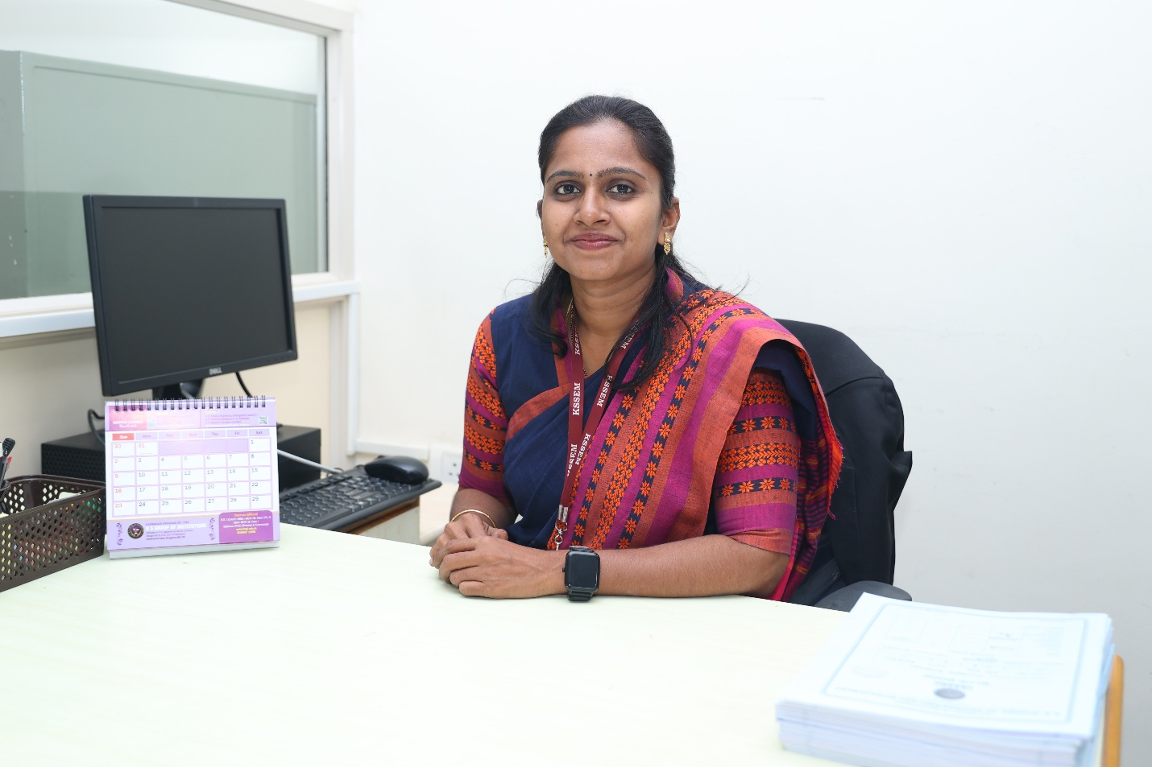](https://kssem.edu.in/images/2c9f8d418c0d8e70018c806fa5040043_image.JPG)

**Mrs. K Padma Priya**

**Assistant Professor**

B.E ,M.Tech

[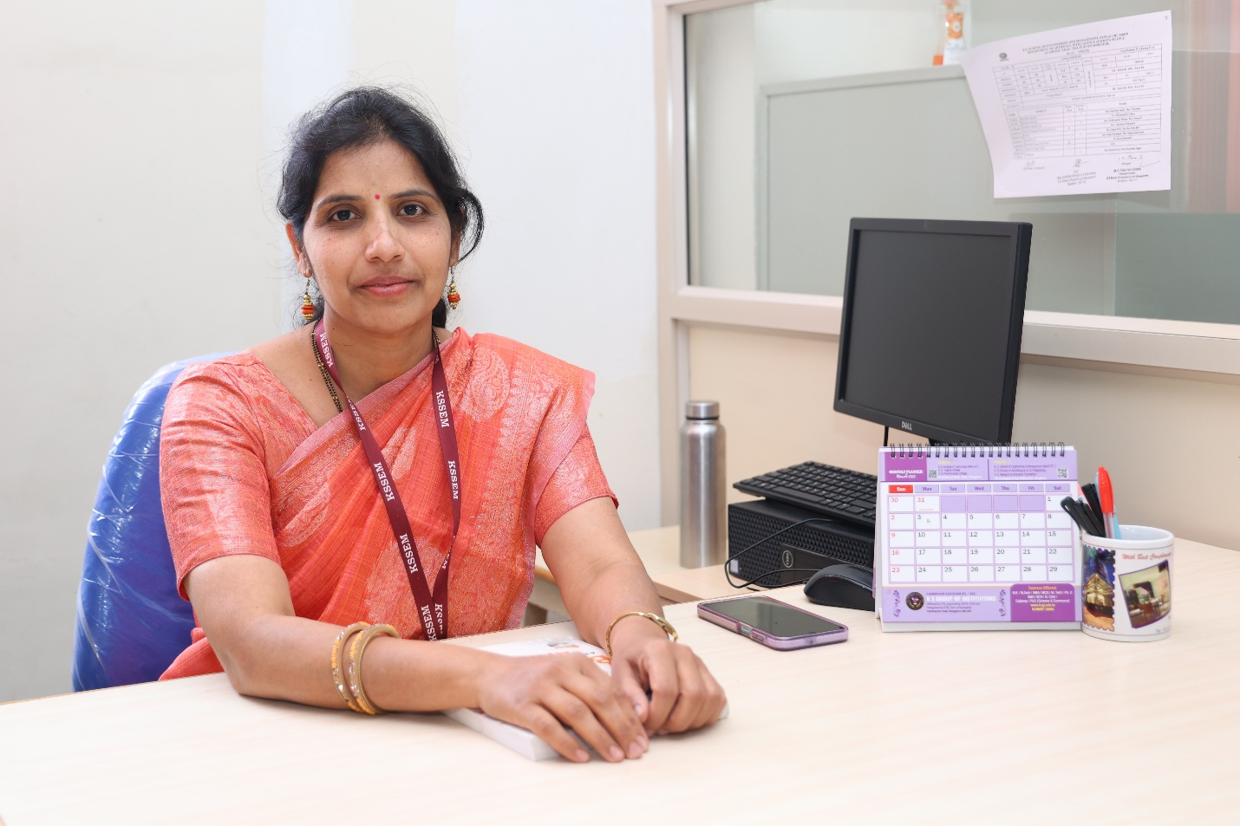](https://kssem.edu.in/images/2c9f8d418c0d8e70018c8071548e0044_image.JPG)

**Mrs. Rajashree D Ingale**

**Assistant Professor**

B.E, M.Tech

[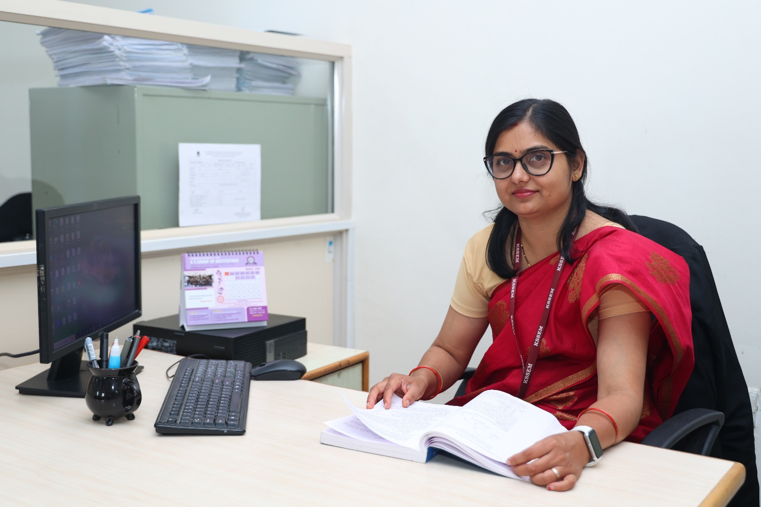](https://kssem.edu.in/images/2c9f8d418f5aa671018f5b9c6ead0000_image.JPG)

**Mrs.Tanushree Mohapatra**

**Assistant Professor**

BE, MTech

[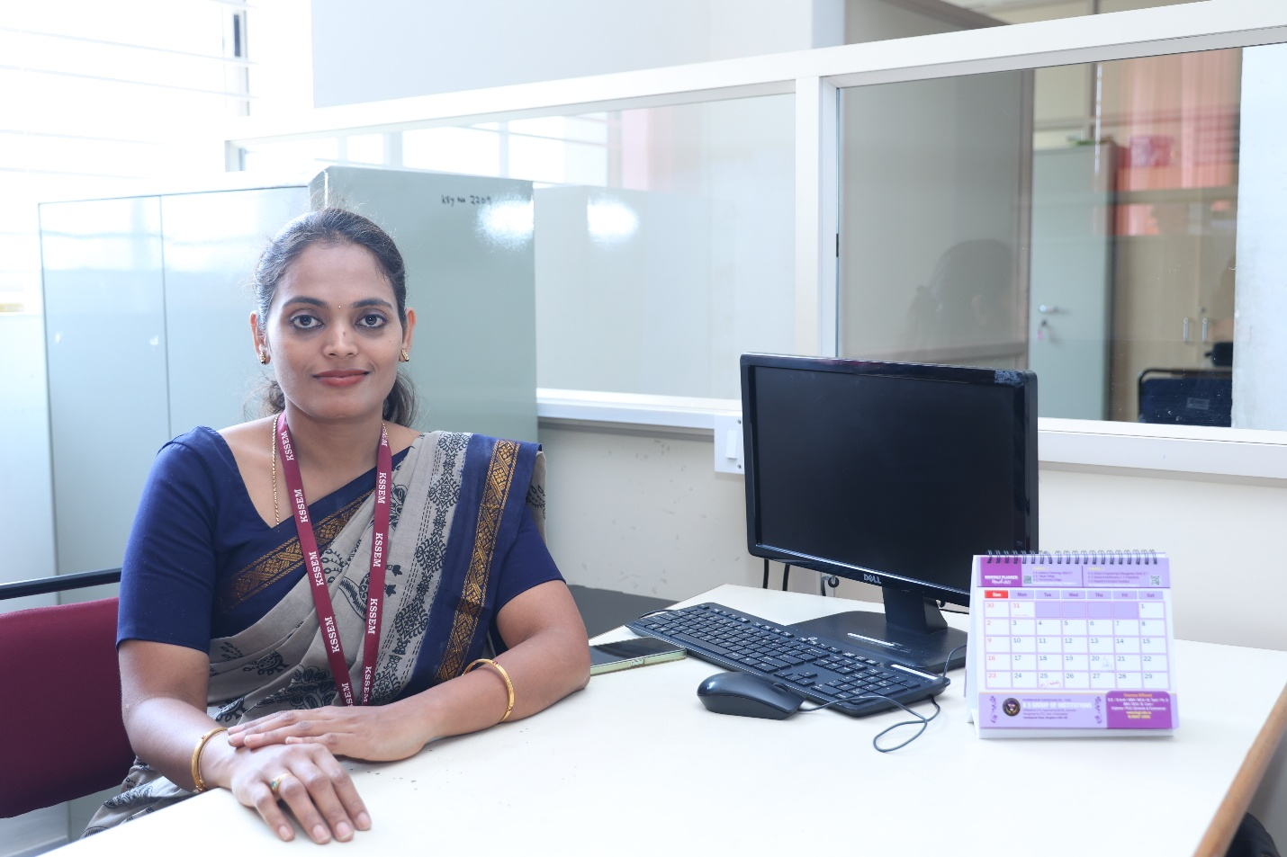](https://kssem.edu.in/images/2c9f8d4191dfaaf00191dfb115550000_image.JPG)

**Mrs.Kavyashree yadav J**

**Assistant Professor**

BE, MTech

[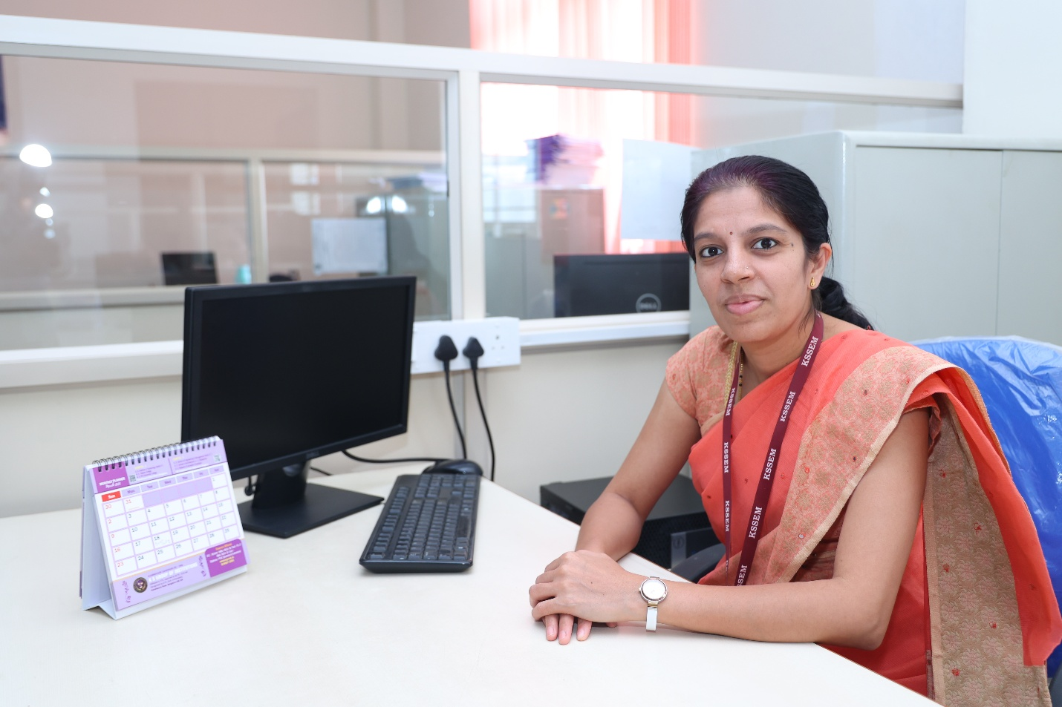](https://kssem.edu.in/images/2c9f8d4191dfaaf00191dfba38e40001_image.JPG)

**Mrs. Shilpa Sannamani**

**Assistant Professor**

BE(CSE), M.Tech.(CSE)

**Supporting Faculty**

[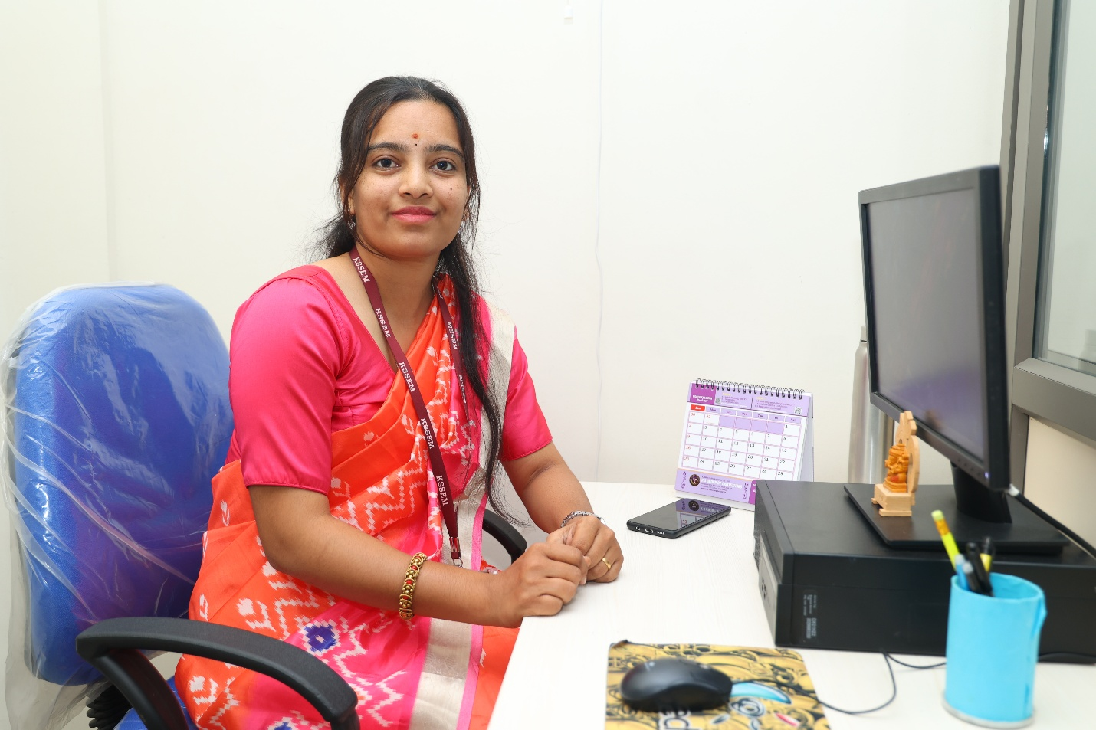](https://kssem.edu.in/images/2c9f8d4187ff658201888f3bdc47005c_image.JPG)

**Mrs. Pallavi V**

**Programmer**

B.E CSE

[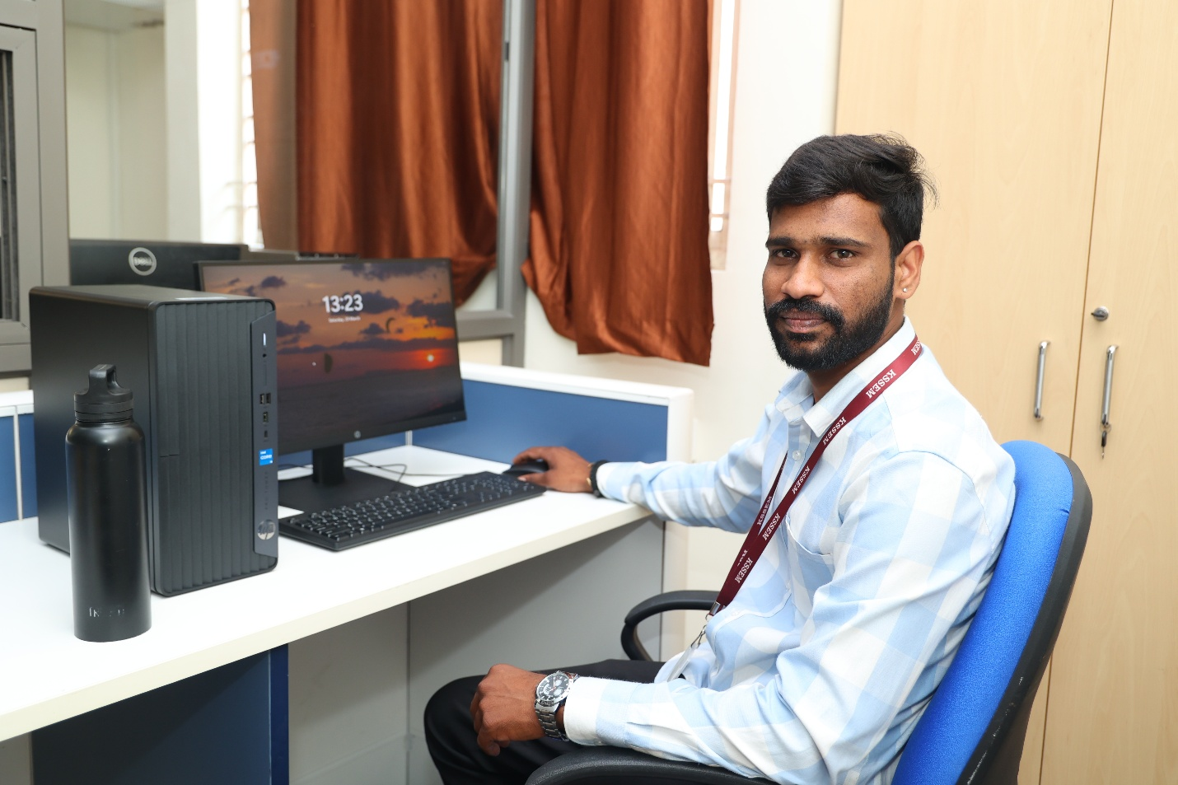](https://kssem.edu.in/images/2c9f8d4187ff658201888fcd8143005d_image.JPG)

**Mr. Naresh P G**

**Programmer**

B.Sc. Computer Sciences

[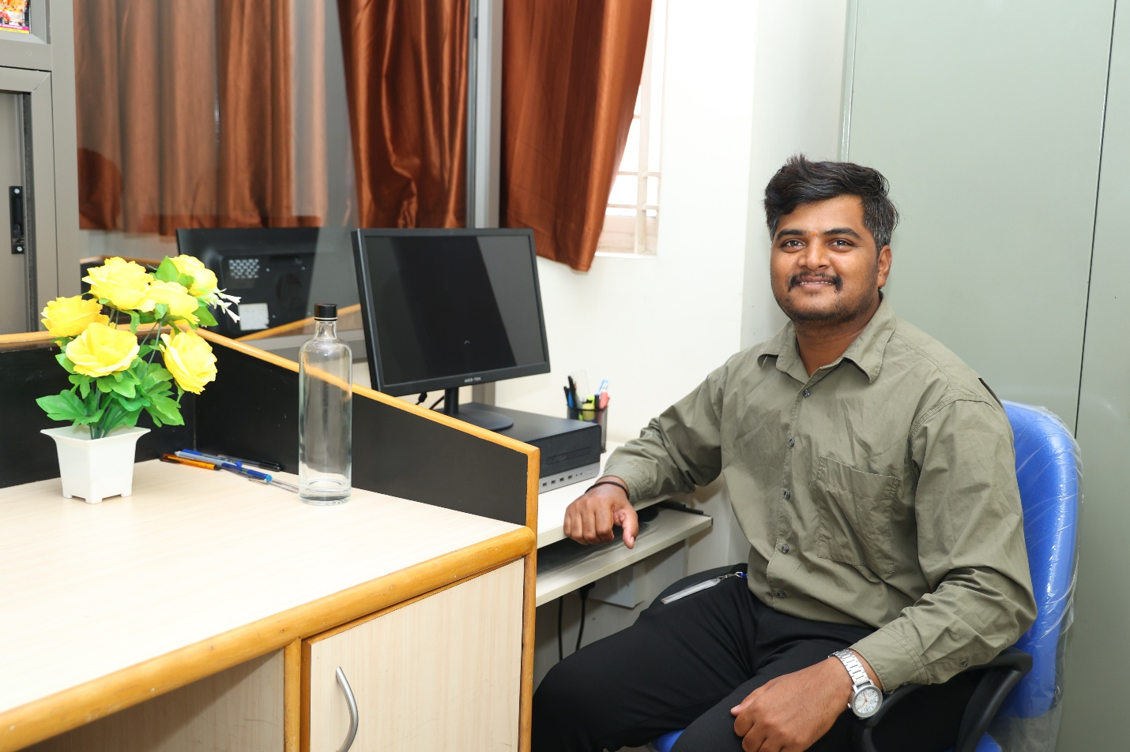](https://kssem.edu.in/images/2c9f8d4188dc95000188ec11faf9000e_image.JPG)

**Mr. Manjunath S**

**Programmer**

B.E EEE

[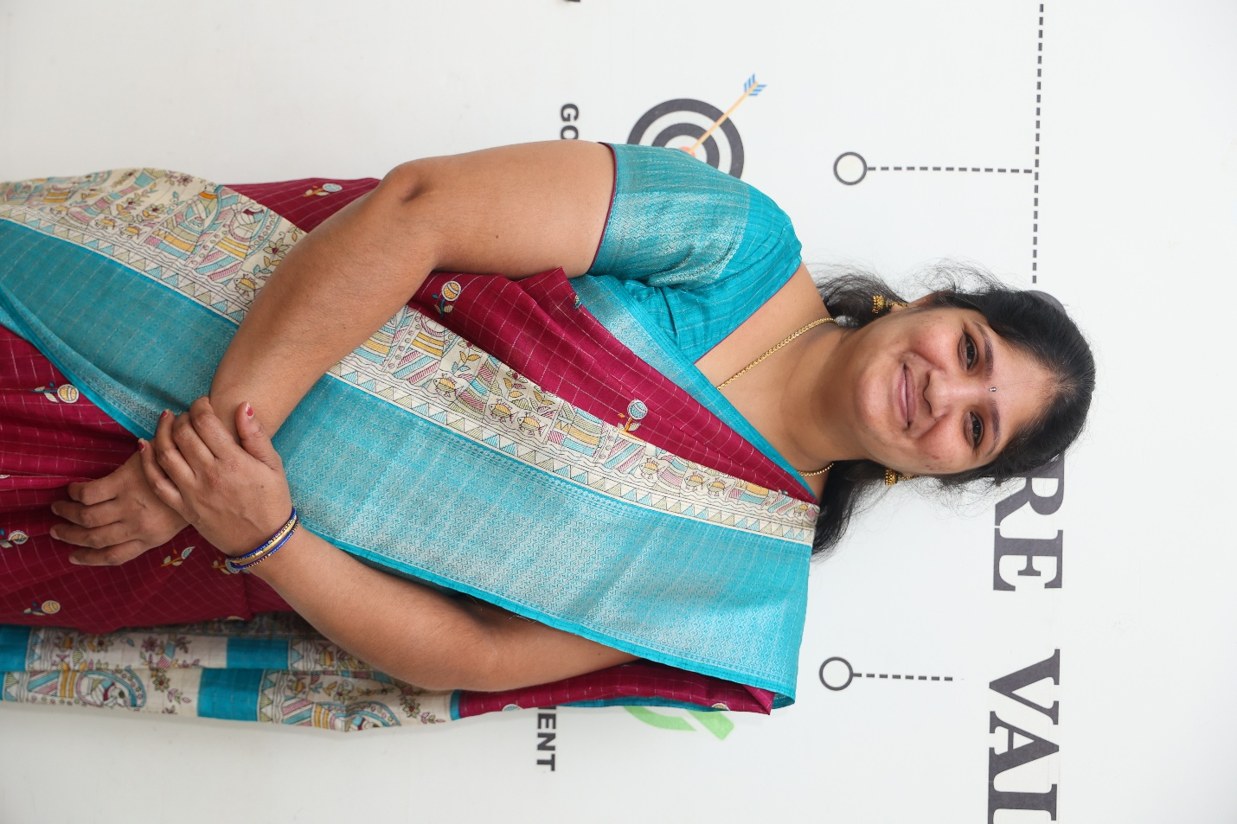](https://kssem.edu.in/images/2c9f858d9341b823019342f9053b0001_image.JPG)

**Mrs.Kalpana**

**Attender**

SSLC

[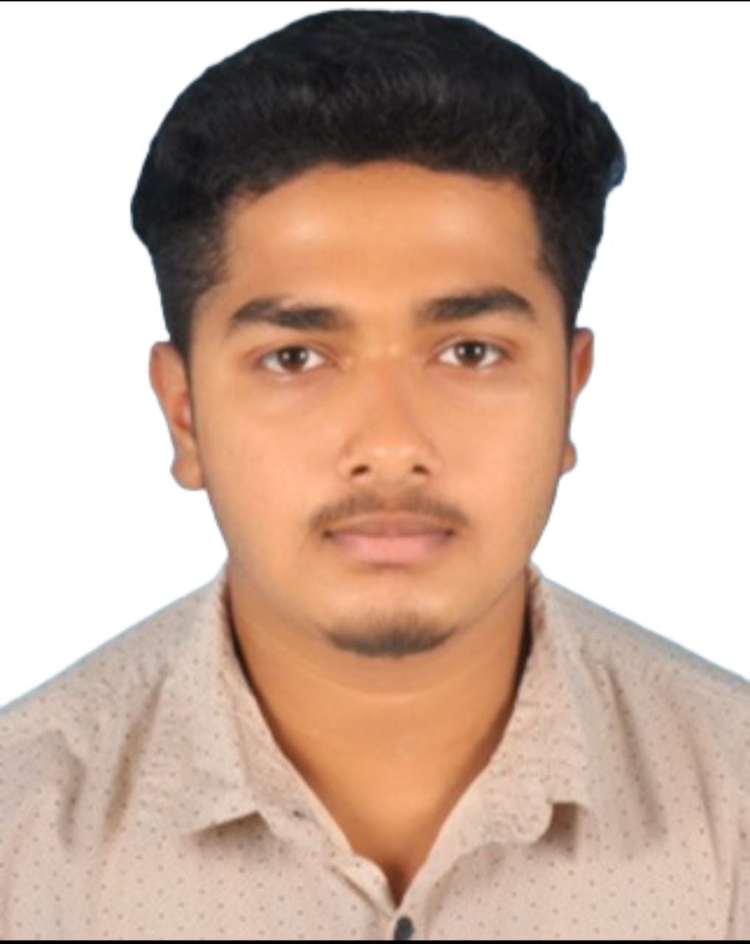](https://kssem.edu.in/images/1754733679837_image.jpeg)

**Bhuvan B**

**Programmer**

B.E(ISE)

[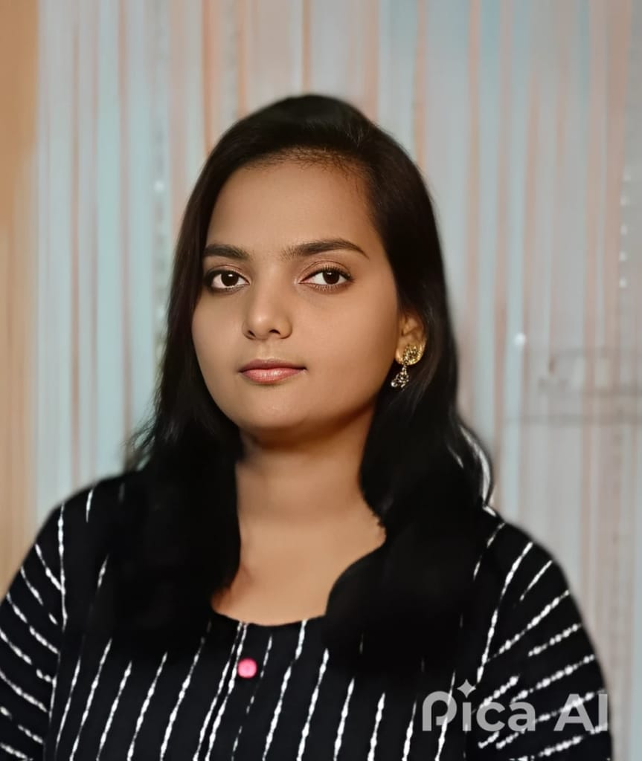](https://kssem.edu.in/images/1754734851684_image.jpeg)

**Dhanuja K N**

**Programmer**

MCA

[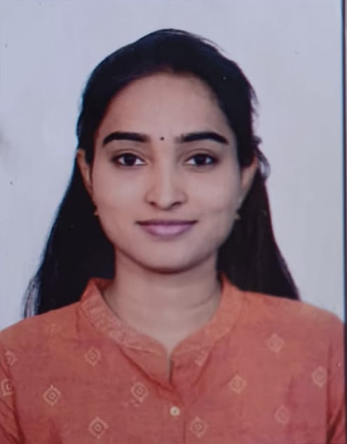](https://kssem.edu.in/images/1754734893618_image.jpeg)

**Harshitha L S**

**Office Assistant**

M.com

[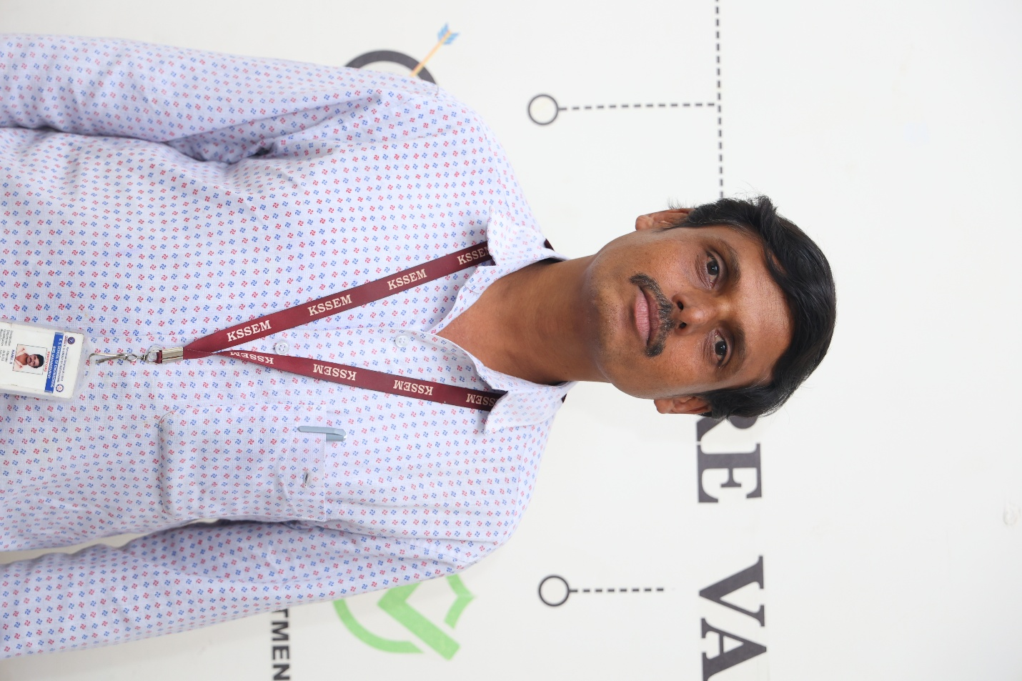](https://kssem.edu.in/images/2c9f8d418b13f419018b21ff23ac0015_image.JPG)

**Mr. Ramu S**

**Attender**

SSLC

[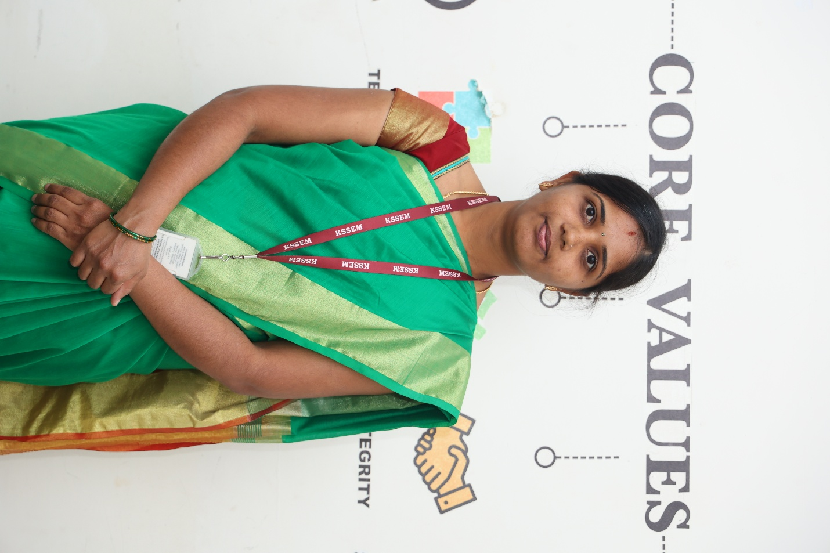](https://kssem.edu.in/images/2c9f8d41921d774201921e475a640000_image.JPG)

**Mrs. Pavithra K M**

**Attender**

SSLC

**Department Labs**

Artificial Intelligence and Data Science Department has fully furnished State of Art laboratories. All laboratories are well-equipped to run the academic laboratories courses. Highly experienced Technical staff are available in all the laboratories to assist the students to carry out their lab sessions.

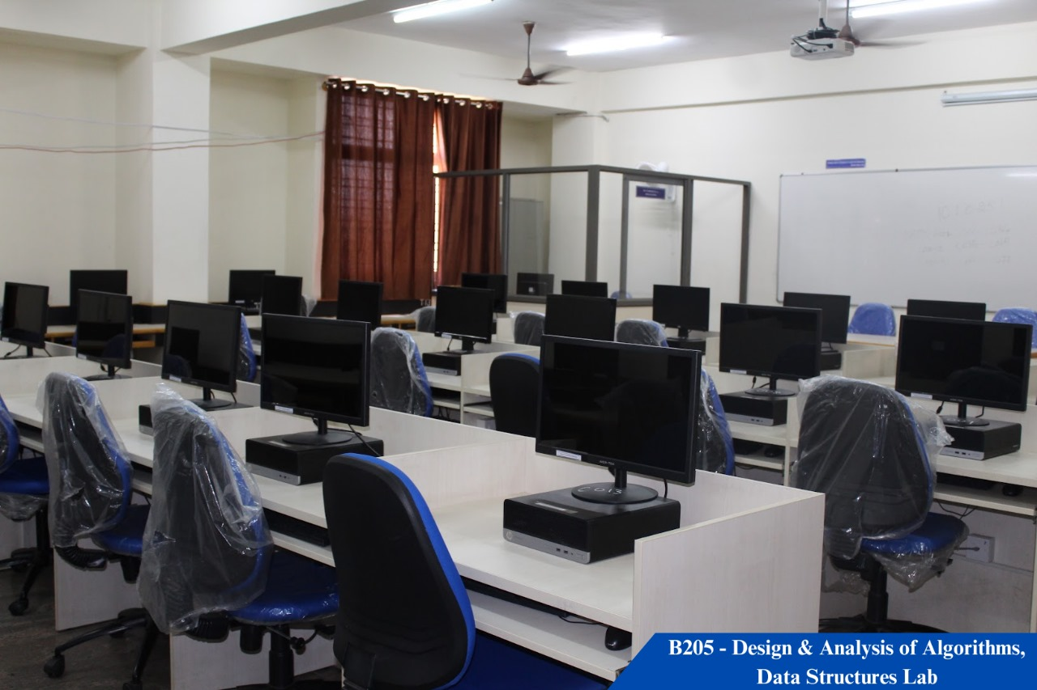

**Data Structure and Design and analysis of algorithm Laboratory**

B-205 , Ground Floor

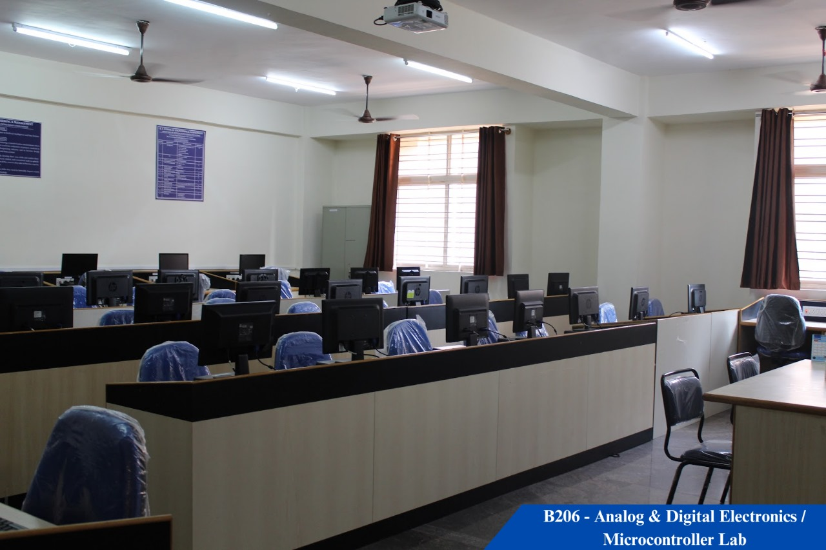

**ADE and Microcontroller Laboratory**

B 206 Ground Floor

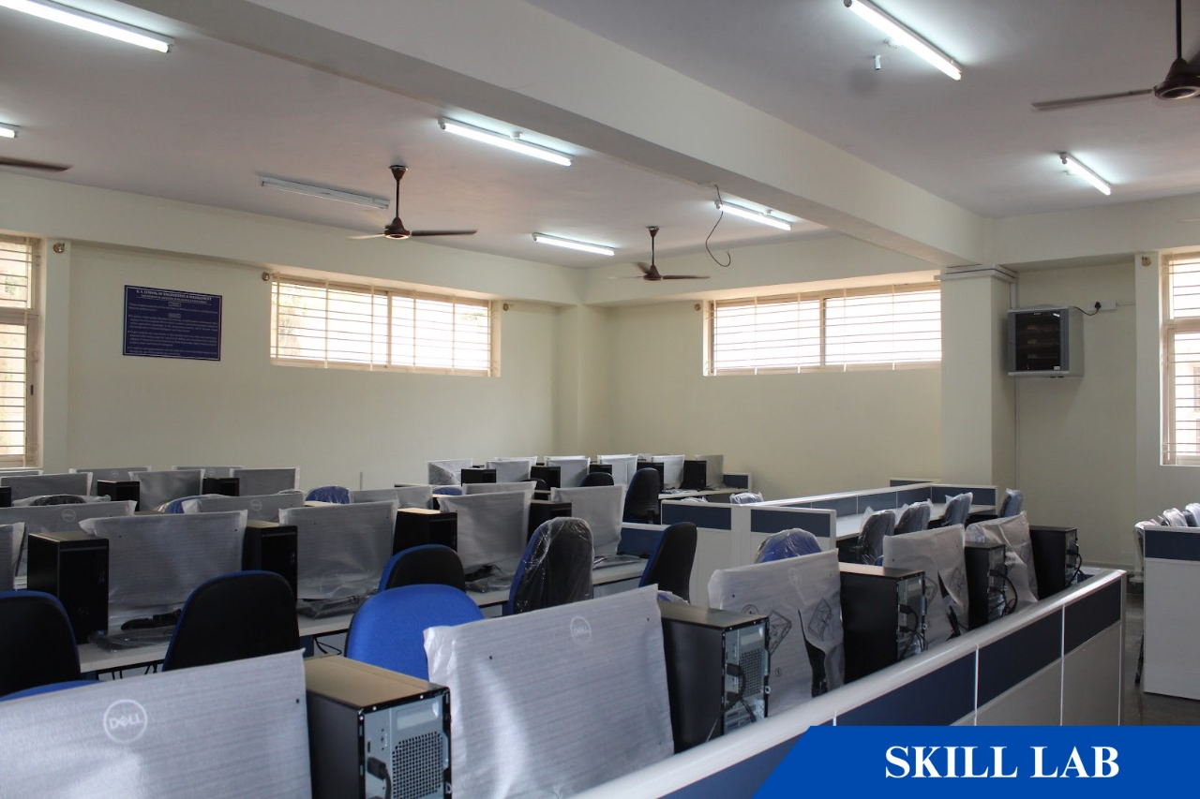

**Skill Lab**

B-207, Ground floor

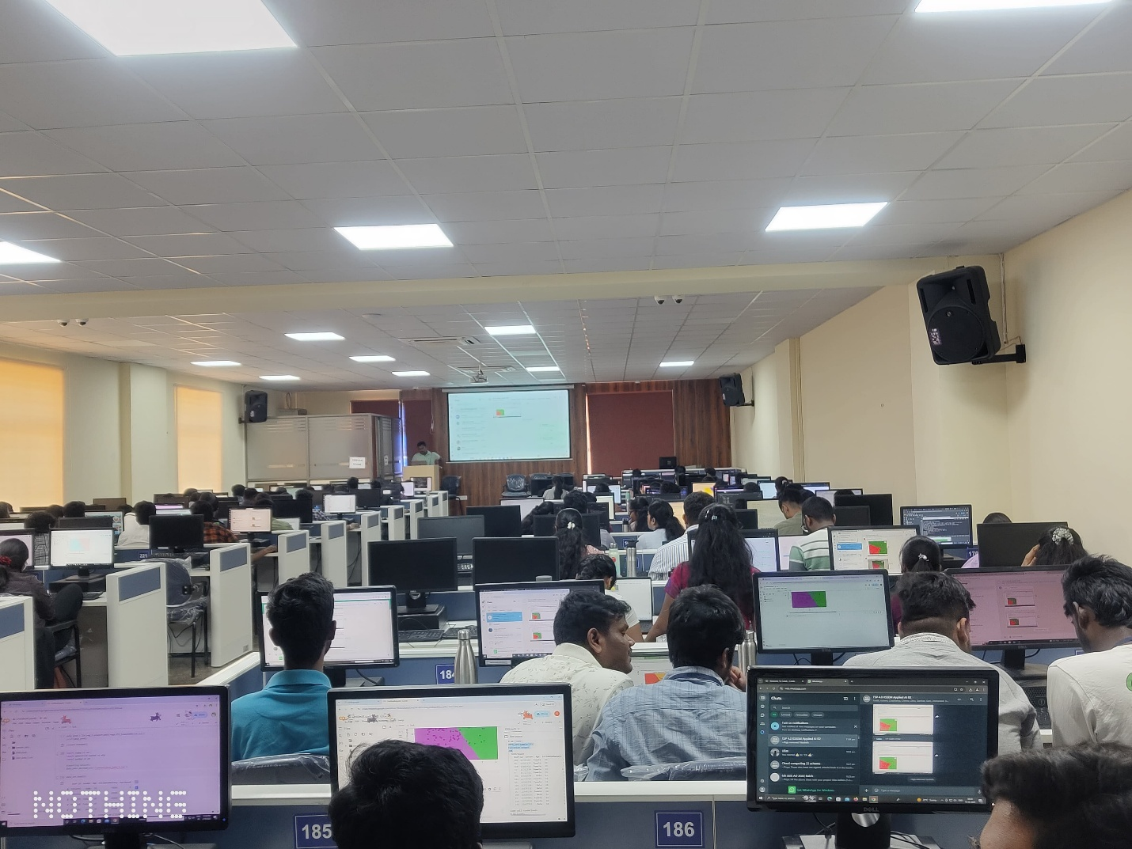

**Alpha-Delta Seminar Hall**

B-208, Ground floor

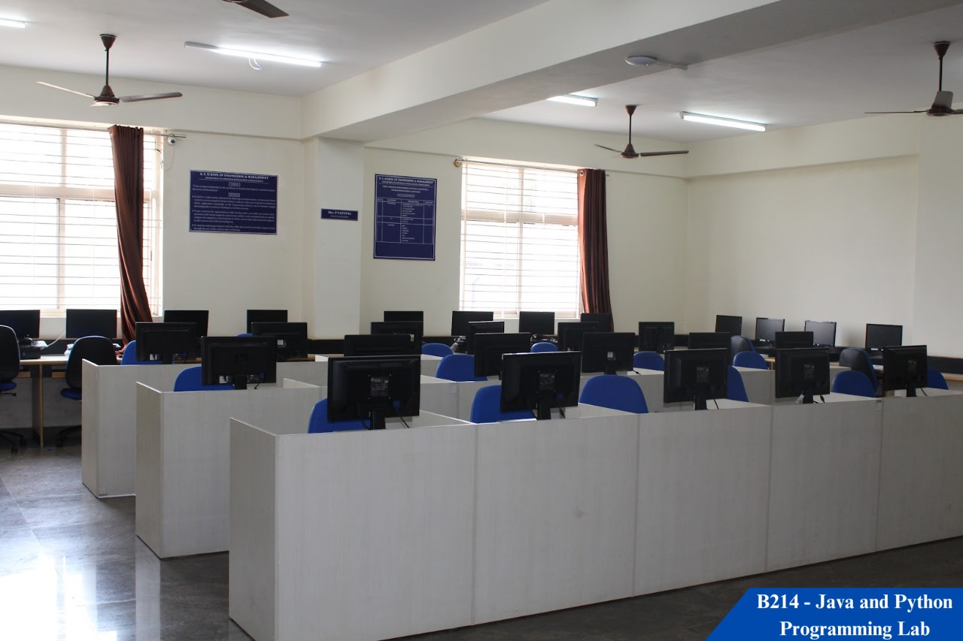

**Object Oriented Programming and Java Laboratory**

B214, Ground Floor

**Departmental Library**

Libraries are established for the systematic collection, organization, preservation and dissemination of knowledge and information. It is very important for person to preserve and maintain the valuable knowledge and information contained in the books and documents because we want to preserve our knowledge and wisdom for the coming generations. By preserving the documents in a library this knowledge can be made available to others so that they can benefit from it.

Libraries play a vital role in the development of any society by enhancing the cause of education and academic research. They cater to the information needs of thousands of peoples.

**Higher Education**

The department conduct higher studies awareness program in order to motivate the students to do higher studies both within the country and abroad. The department in association with training and placement department helps students in understanding the importance of attempting various competitive exams like GATE, IELTS, GRE, TOEFL etc.

High-end Master's programs are: M.S, M.Tech, or M.E. in :

* Artificial intelligence
* Data Science
* Machine Learning
* Embedded systems
* Knowledge-based systems
* Bio-informatics
* Software Engineering
* Systems Engineering.
* Distributed Computing
* Image Processing
* Information Security
* Cyber Security

### Student Club

### Club Activities :

Social and Cultural club [[view here]](https://kssem.edu.in/images/1752554562250_image.pdf)

Literary and communication club [[view here]](https://kssem.edu.in/images/1752554519424_image.pdf)

More clubs

Internships are foundational in preparing students for the workforce and providing opportunities after graduation. Most employers seek career-ready college graduates who have been equipped with prior experiences and skills in a given field. An internship is important because it can present you with new skills and opportunities that student would not receive otherwise. Interns not only gain technical knowledge within the industry of their choice, but they also learn how to interact with professionals in a workplace setting, and develop essential soft skills like time management, organization, adaptability, problem-solving and teamwork. An internship is the best way to gain work experience as a student. Internships give you the valuable practical experience needed along with theoretical knowledge. Employers often note that there is a disconnect between the requirements of the industry and the academics. This gap can be bridged by an internship and pitch you as an ideal candidate.

Internship 2021 Batch [[view here]](https://kssem.edu.in/images/1756181808964_image.pdf)

**Projects**

Final year project is one of the most important aspects of Engineering degree. Final year project will be the first exposure to the full rigour of Engineering practice. It is essential that students learn from this exposure and practise all of the engineering methodologies involved. It is particularly important that students learn not just to apply what they know, but to apply it with judgement.

List of Projects batch 2021 [[view here]](https://kssem.edu.in/images/1750652850042_image.pdf)

Projects Description 2021 batch [[view here]](https://kssem.edu.in/images/1750653021298_image.pdf)

**Mini-Projects**

Mini projects for engineering students give an edge over the race of recruitment to work hard to ensure a good career. By taking up mini projects, students can gain practical knowledge. The technical skills can only be improved by taking up mini projects. Students become more productive.

Mini project details (2021 batch) [[view here]](https://kssem.edu.in/images/1731618636172_image.pdf)

Mini project details (2022 batch) [[view here]](https://kssem.edu.in/images/1731618767220_image.pdf)

**Industrial Visit**

Objectives of industrial visit is to provide students an insight regarding internal working of companies. Students know, theoretical knowledge which is not enough for making a good professional career. With an aim to go beyond academics, the department conducts industrial visit provides student a practical perspective on the world of work. The department also provides the visit to premier institutions like IISc and IIIT during Open Day and Open House respective events to give students awareness to newer technologies that help them in deciding the project topics during their final year.

**Events**

**Expert talk on "RESUME BUILDING"**

" To equip students with the skills to create a professional resume that effectively highlights their academic achievements, projects, and relevant skills, enabling them to secure internships and entry-level positions."

2025-10-06

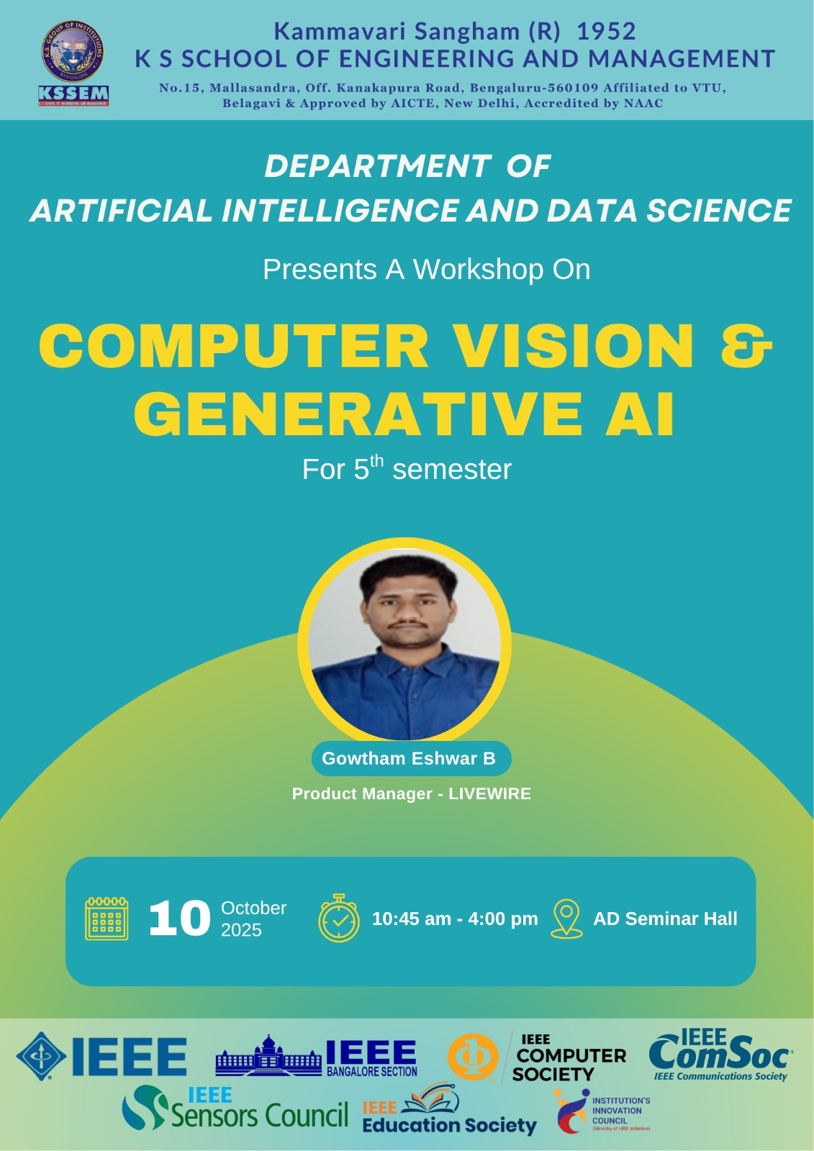

**Computer Vision & Generative AI**

"To equip students with practical knowledge and technical skills in Computer Vision and Generative AI. The workshop aimed to bridge academic learning with industry practices by offering hands-on experience in object detection using YOLOv8 and OpenCV, prompt engineering with LLMs and APIs, and AI integration with IoT and cloud platforms."

2025-10-10

**Generative Al Literacy**

"The workshop aimed to provide a comprehensive understanding of Generative AI and its applications in literature. It was designed to equip participants with both theoretical knowledge and practical skills required to use AI in creating, analyzing, and enhancing textual content. The focus was on exploring how AI can assist in creative writing, academic research, content summarization, and other literary applications."

2025-09-29

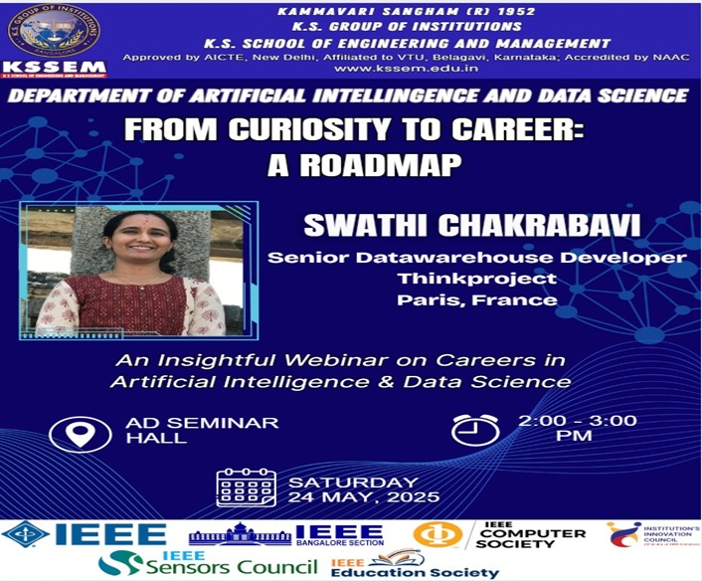

**A webinar on Curiosity to career -A Roadmap**

"Department of AI&DS Conducted A Webinar on Curiosity to Career ? A Roadmap was organized to guide students on transforming their curiosity into meaningful career opportunities. The session highlighted skill-building, industry trends, and strategies for shaping a successful professional journey."

2025-05-24

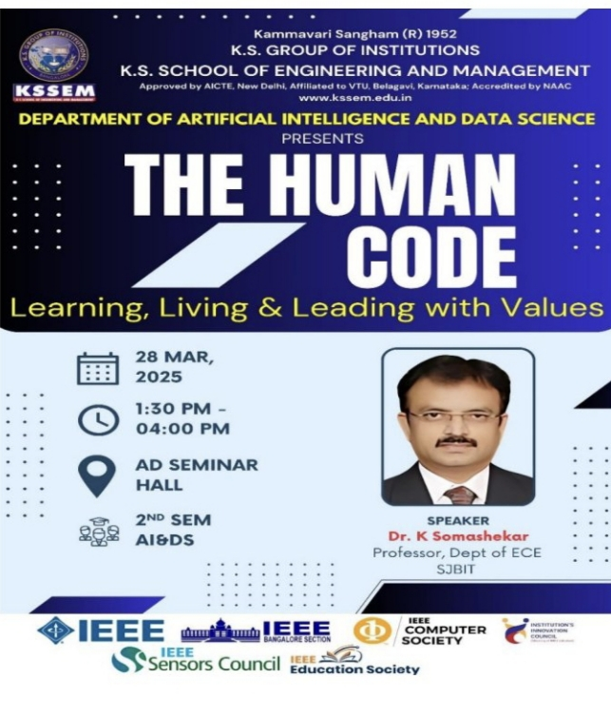

**The Human Code Learning Living and Leading with Values**

"Department of Artificial Intelligence and Data Science organized an expert talk nn Department of AI&DS organized Talk on" The human code: Learning, Living & Leading with Values"."

2025-03-28

**Data science awareness workshop**

"The AI&DS department conducted a Data Science Awareness Workshop to introduce students to the fundamentals and real-world applications of Data Science. The session covered key concepts like data preprocessing, machine learning, and visualization, highlighting its importance in industry and research. "

2025-03-03

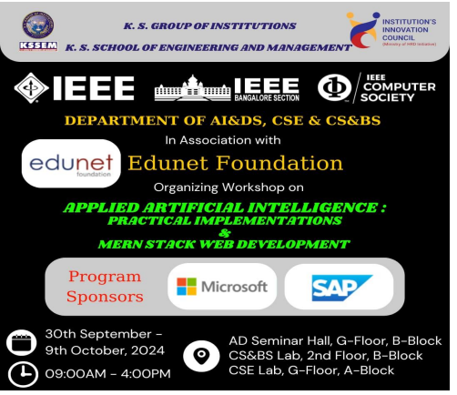

**Applied Artificial Intelligence practical implementation**

"The AI & DS department conducted a Workshop on Applied AI to expose students to practical applications of Artificial Intelligence in solving real-world problems. The session emphasized hands-on learning in areas like machine learning, natural language processing, and computer vision, bridging theory with industry use cases."

2024-09-30

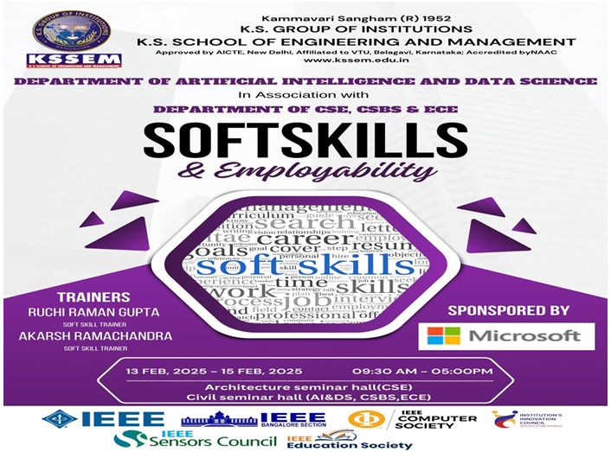

**SoftSkills Employability**

"The AI & DS department organized a Soft Skills and Employability Workshop to enhance students? communication, teamwork, and professional readiness. The session focused on building confidence, interview preparation, and essential workplace skills to improve career opportunities."

2025-02-13

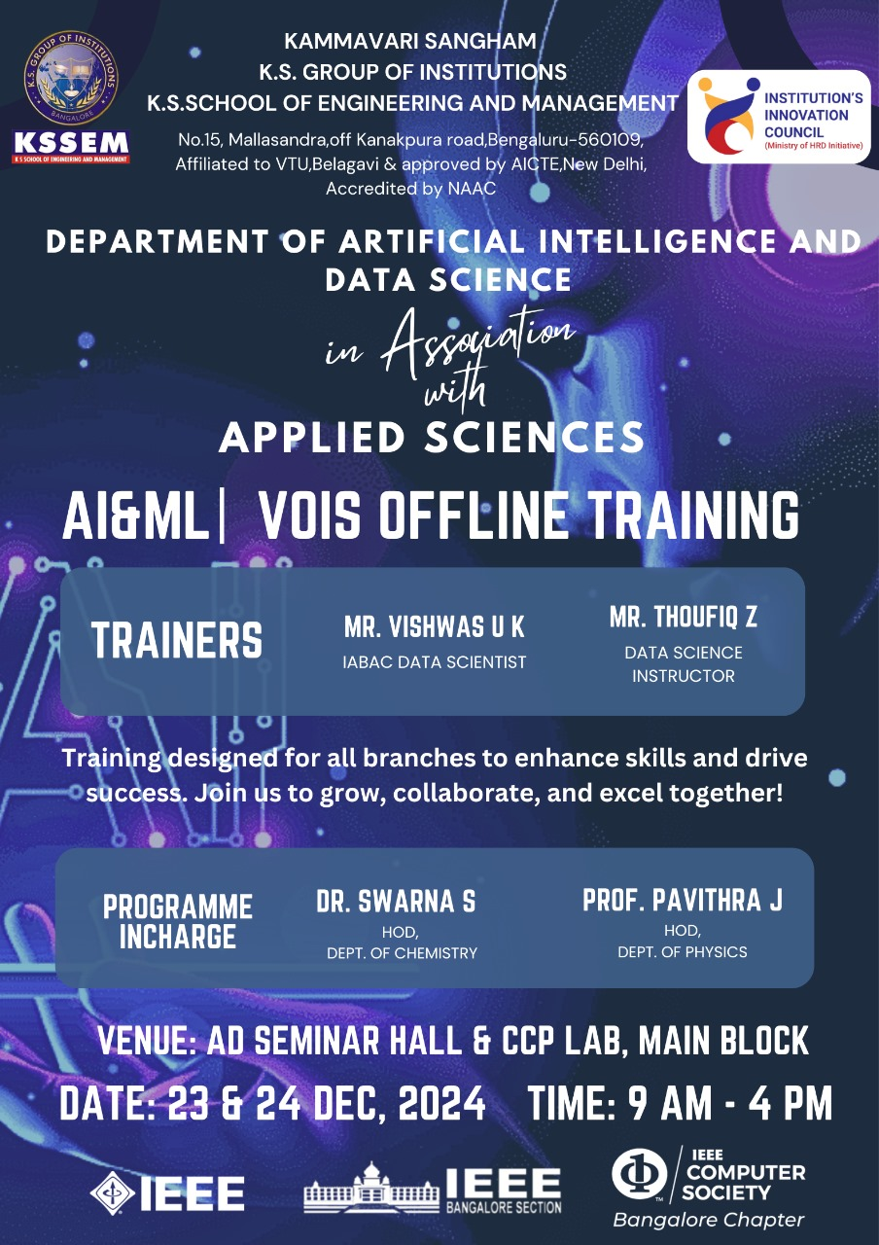

**AI&ML VOIS Offline Training**

"The AI & DS department organized an AI & ML VOIS Offline Training program in collaboration with VOIS to provide students with hands-on experience in Artificial Intelligence and Machine Learning. The training focused on real-world projects, industry practices, and skill-building to enhance employability."

2024-12-24

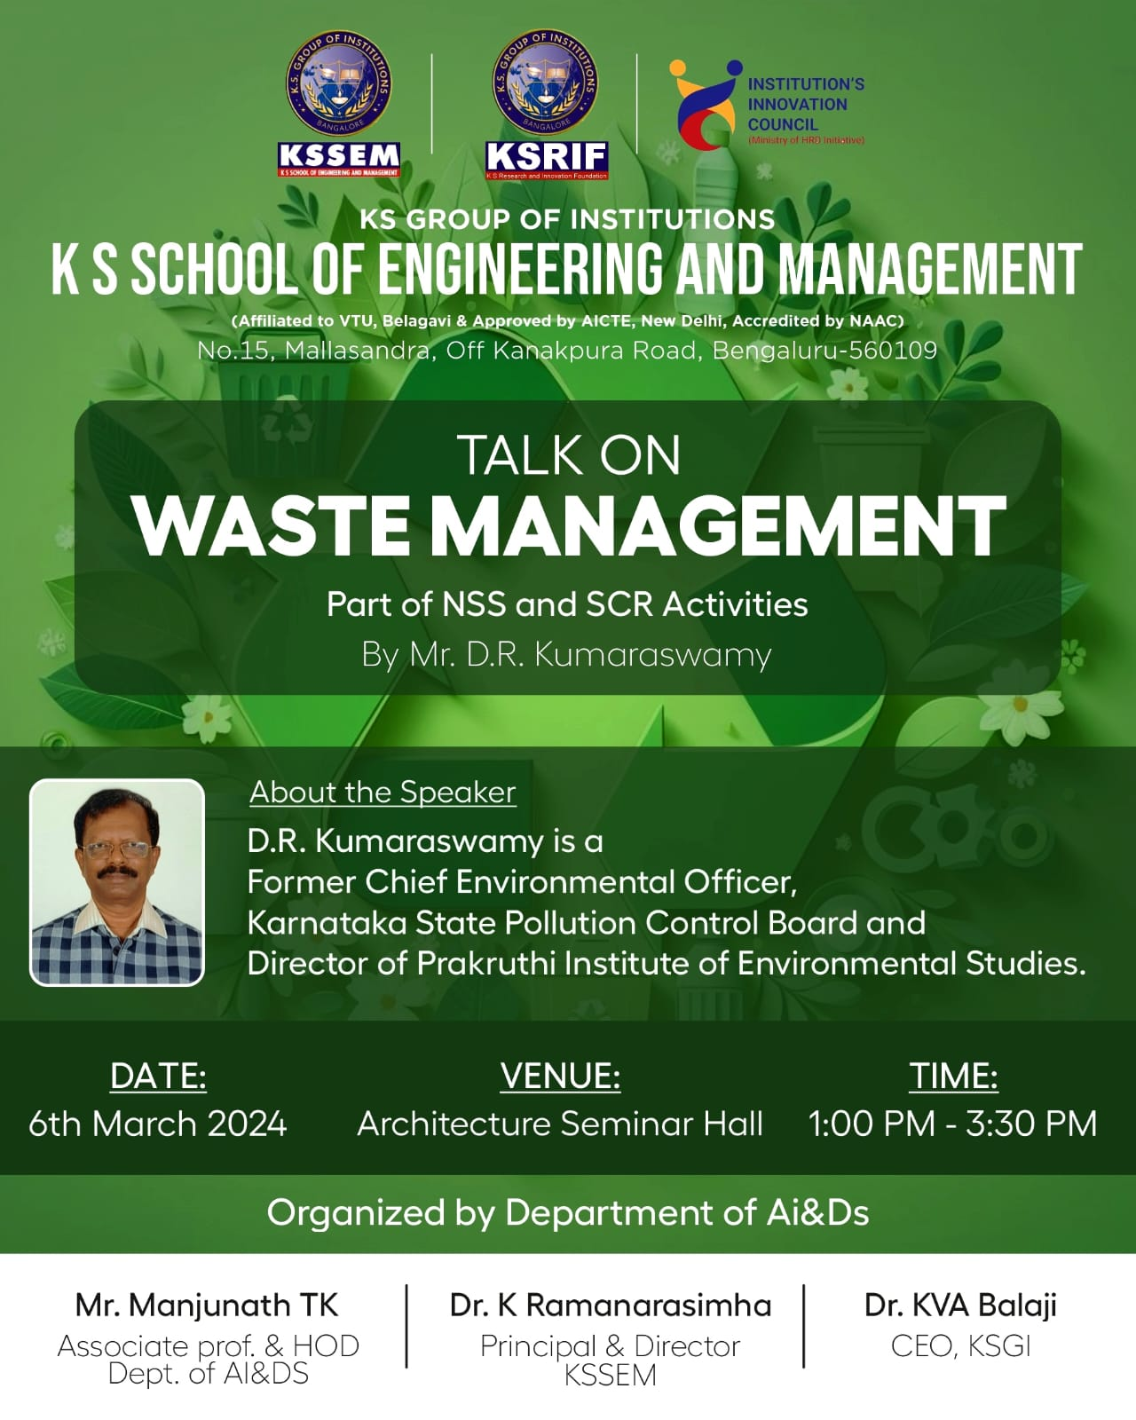

**Expert Talk on Waste Management**

"Department of Artificial Intelligence and Data Science in association with Mechanical department organized a talk on Waste management for III semester AI&DS, Mechanical and Civil students ."

2024-11-22

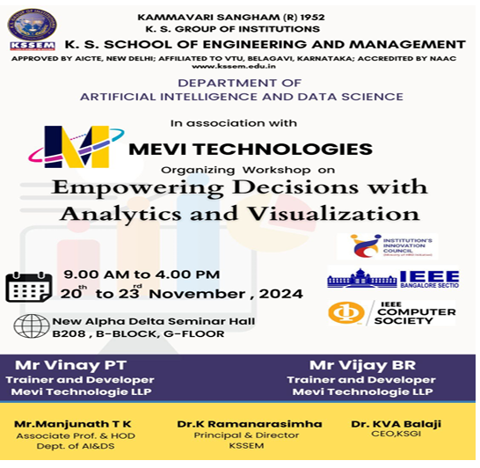

**Empowering Decisions with Analytics and Visualization**

"To equip students with practical data analytics and visualization skills using industry tools like SQL and Power BI."

2024-11-20

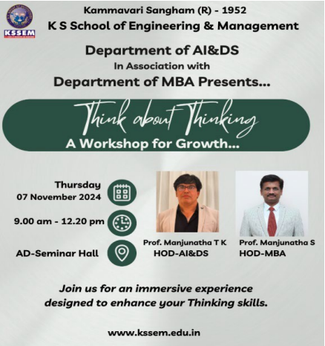

**Expert Talk on Think about Thinking**

"To empower final-year students with critical thinking and decision-making skills through an interactive session that encourages self- reflection, challenges assumptions, and fosters strategic thinking for personal and professional growth."

2024-11-07

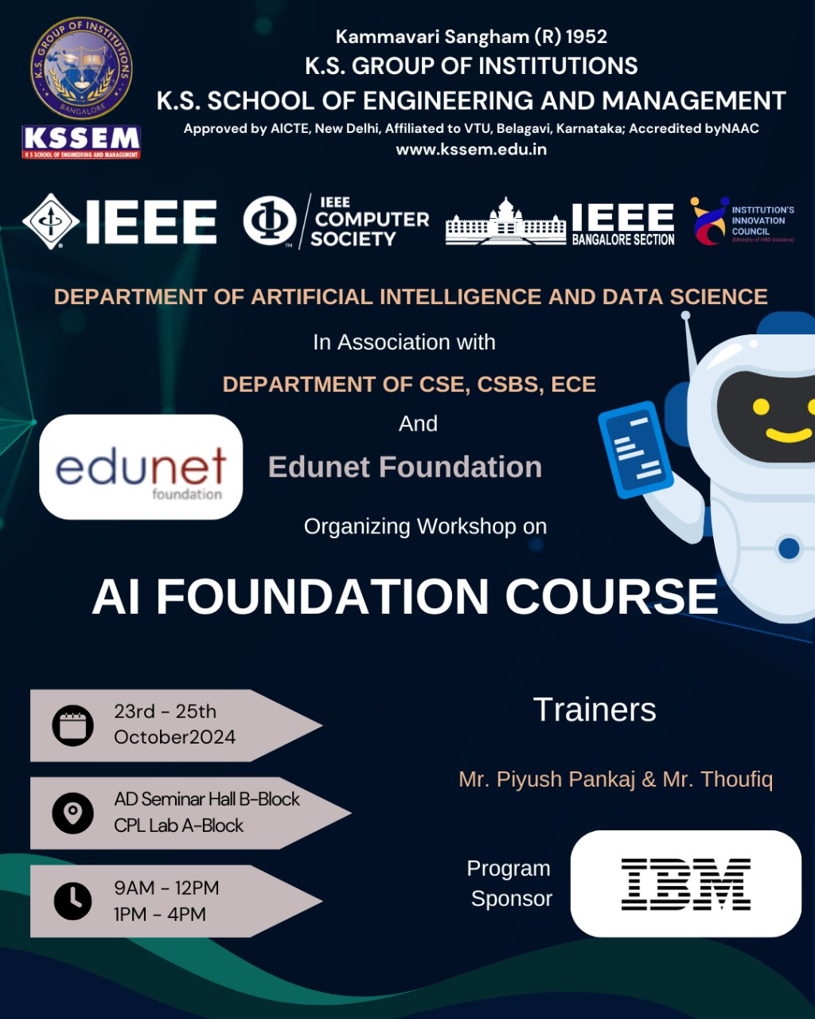

**Workshop on AI Foundation Course**

"AI & DS department has organised a 3 days workshop on AI Foundation course for 3rd semester students from 23-10-24 to 25-10-24"

2024-10-23

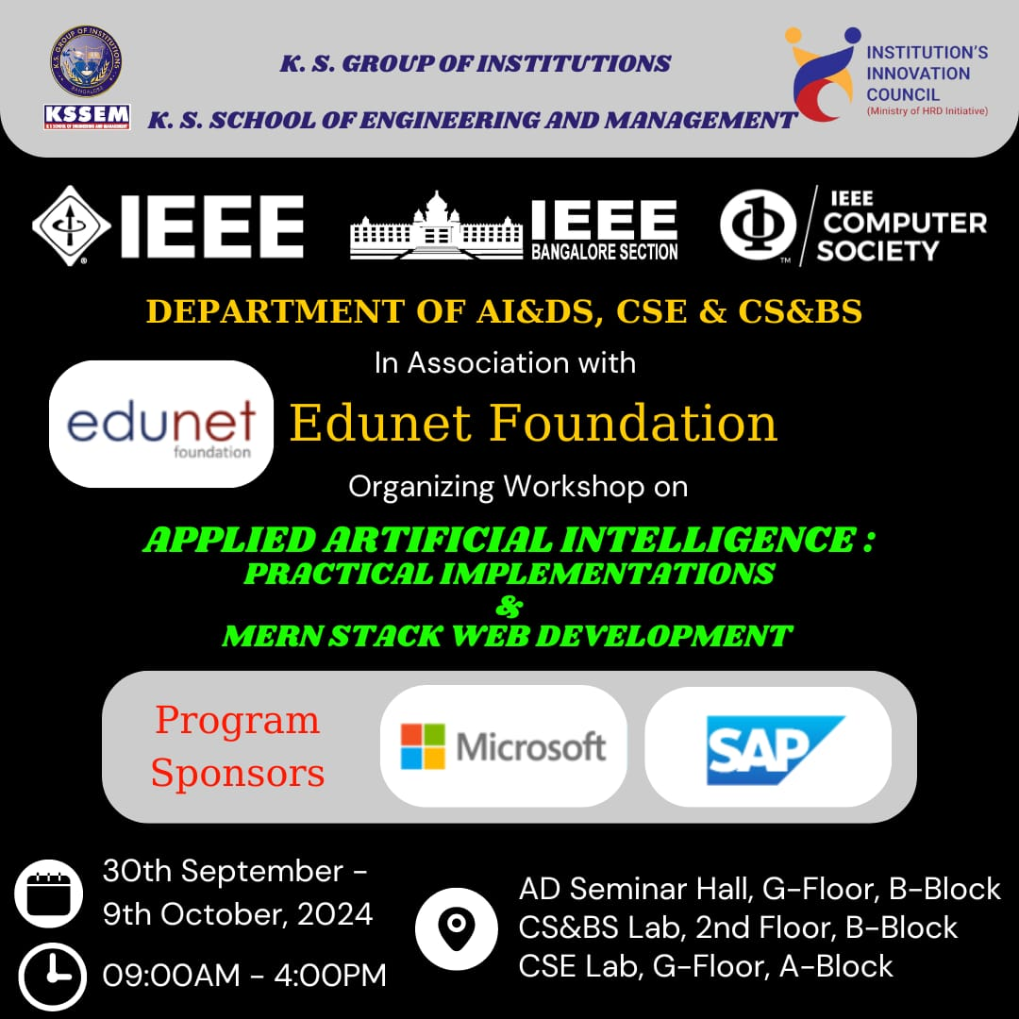

**Workshop on Apllied Artificial Intelligence**

"Department of AI & DS organised a workshop on Applied Artificial Intelligence from 30-9-24 to 09-10-24.It was conducted by Edunet Foundation sponsored by Microsoft and SAP"

2024-09-30

**Ifosys Spring Board -SEP Program Softskills training**

"The Soft Skills & Employability Training sponsored by Microsoft aimed to equip participants with essential professional skills to enhance their career readiness."

2025-02-15

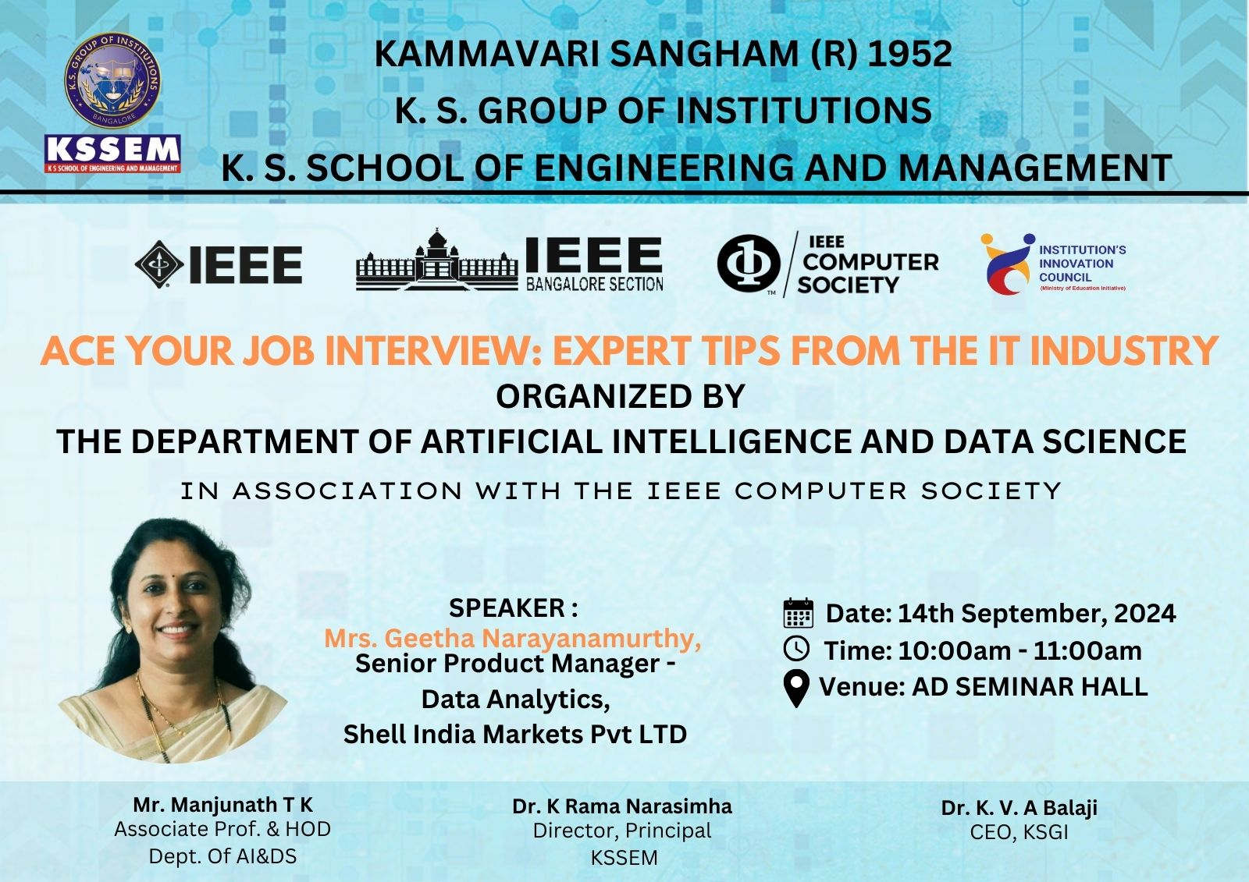

**ACE your Job Interview: Expert tips from IT Industry**

"Department of Artificial Intelligence and Data Science organized an expert talk on how to face job interview during campus drive and improve their skills by Mrs Geetha Narayanamurthy, Senior product manager, Data Analytics, Shell India Pvt. LTD"

2024-09-14

**"Exclusive Orientation Program: Edunet Foundation & IBM Student Developer Program"**

"The department of Artificial Intelligence and Data Science Engineering, KSSEM, in association with IEEE KSSEM Student branch organized a Seminar on, 'Exclusive Orientation Program: Edunet Foundation & IBM Student Developer Program', "

2024-09-04

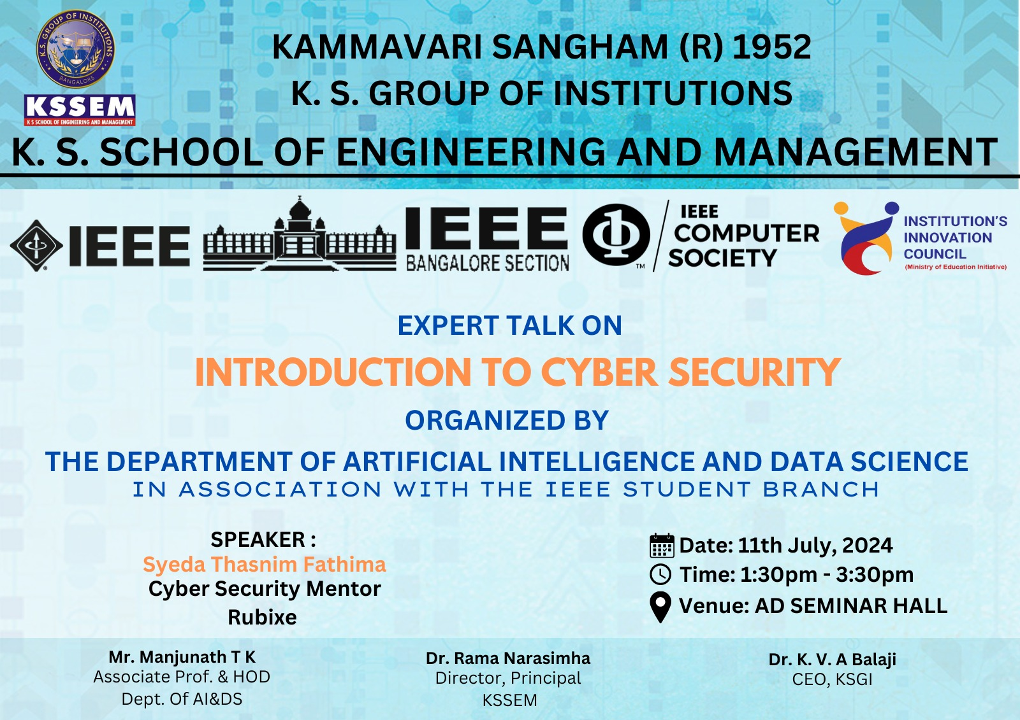

**Expert talk on Introduction to Cyber Security**

"Department of AI&DS Organised expert talk on Introduction to Cyber Security by Syeda Thasnim fathima, cyber security mentor, Rubixe"

2024-07-11

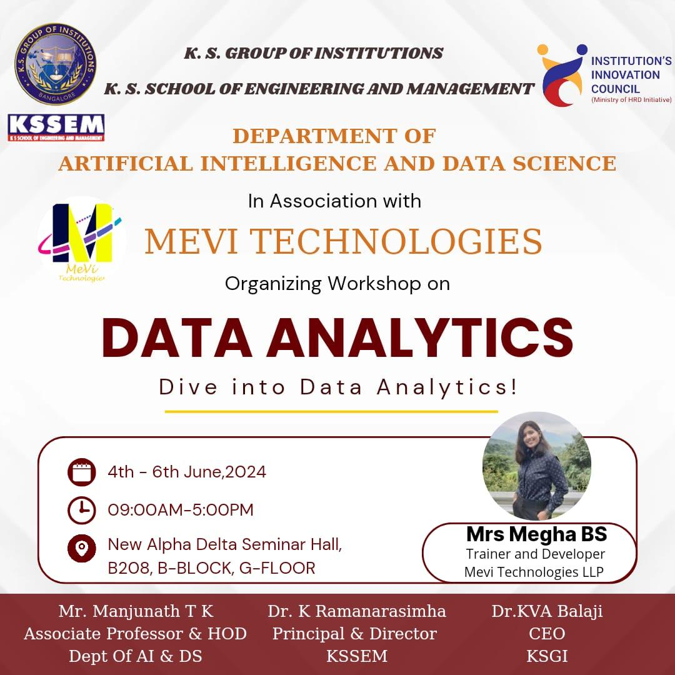

**Data Analytics**

"Department of AI&DS Organised workshop on Data Analytics by Mrs. Megha B S, Trainer and Developer, Mevi Technologies LLP"

2024-06-04

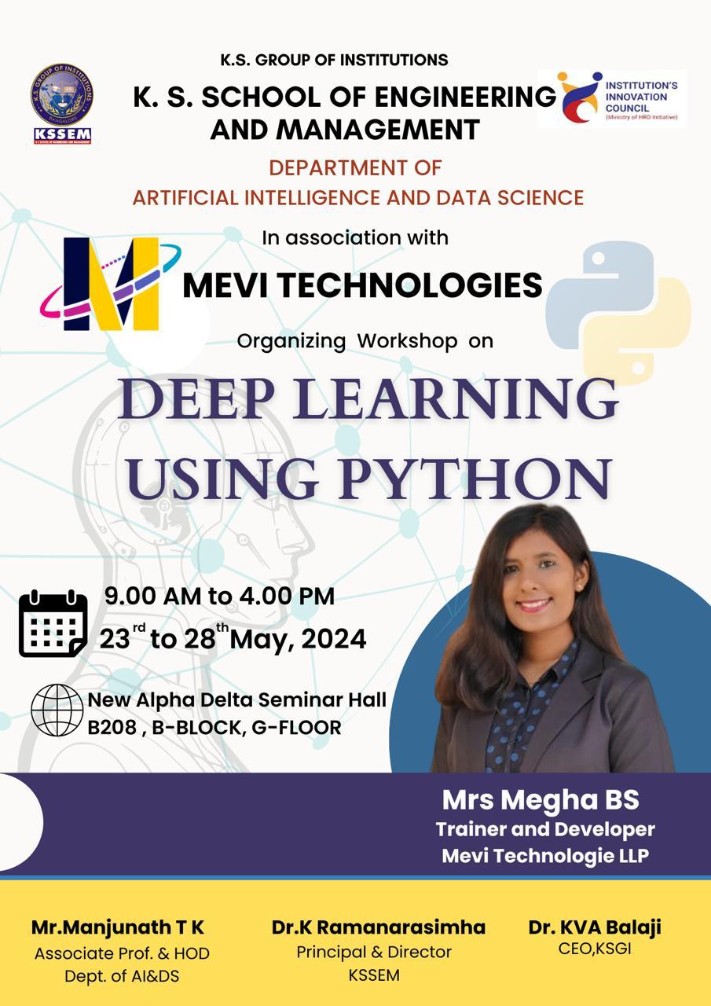

**Deep Learning using python**

"Department of AI&DS Organised workshop on Deep Learning using Python by Mrs. Megha B S, Trainer and Developer, Mevi Technologies LLP"

2024-05-23

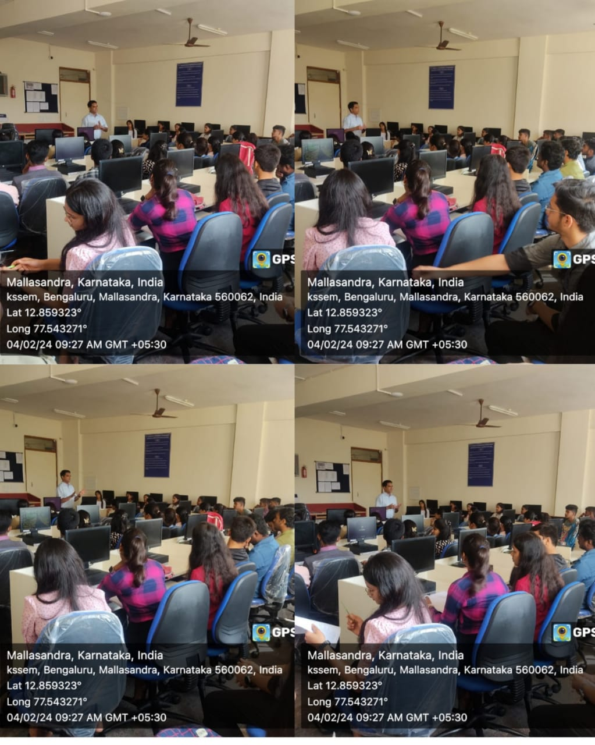

**Expert talk on Advanced DAA**

"Department of AI&DS organized expert talk on Advanced DAA -Guide to successful interview by Dr. Girish Salanke "

2024-02-04

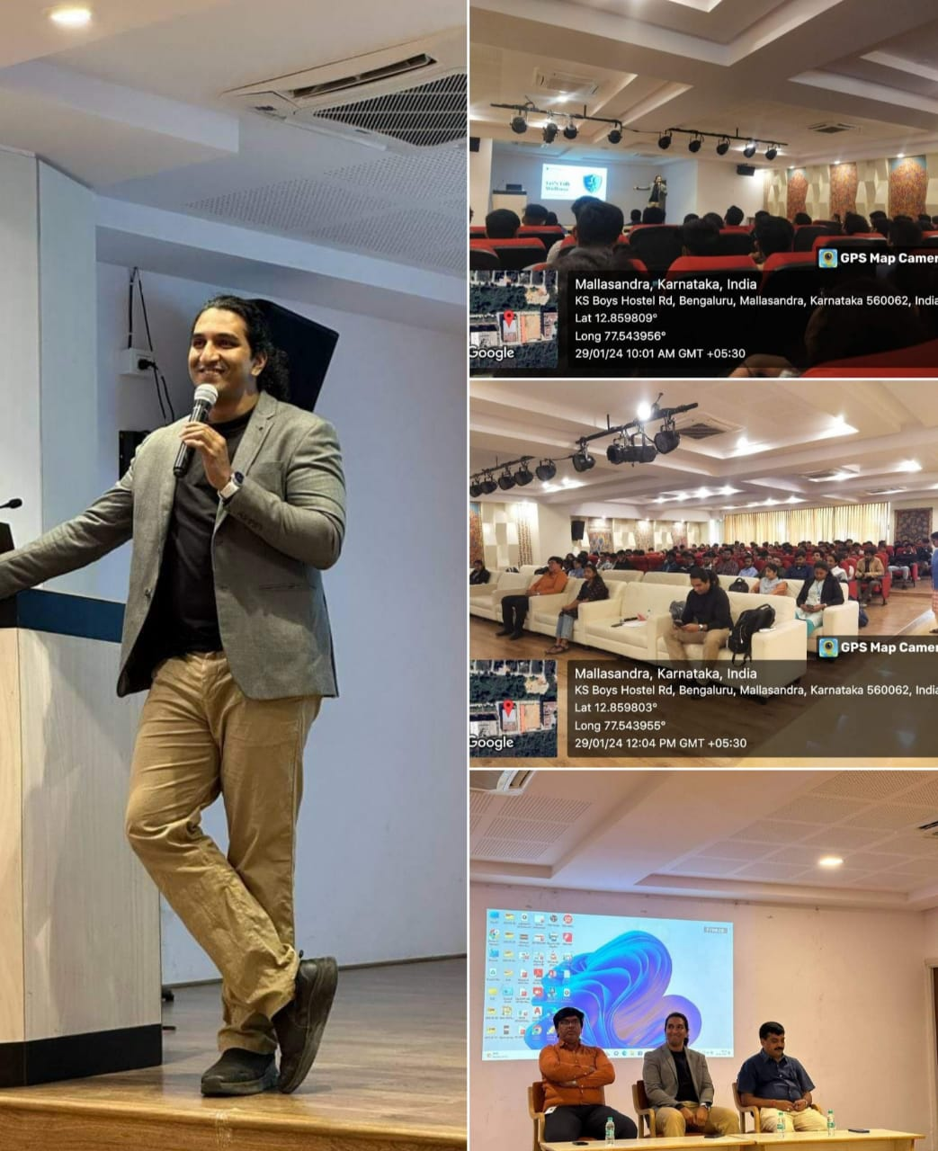

**Expert Talk on Health,Nutrition and Fitness**

"Department of AI&DS Organized Expert Talk on Health,Nutrition and Fitness by Mr. Rajeev H B"

2024-01-29

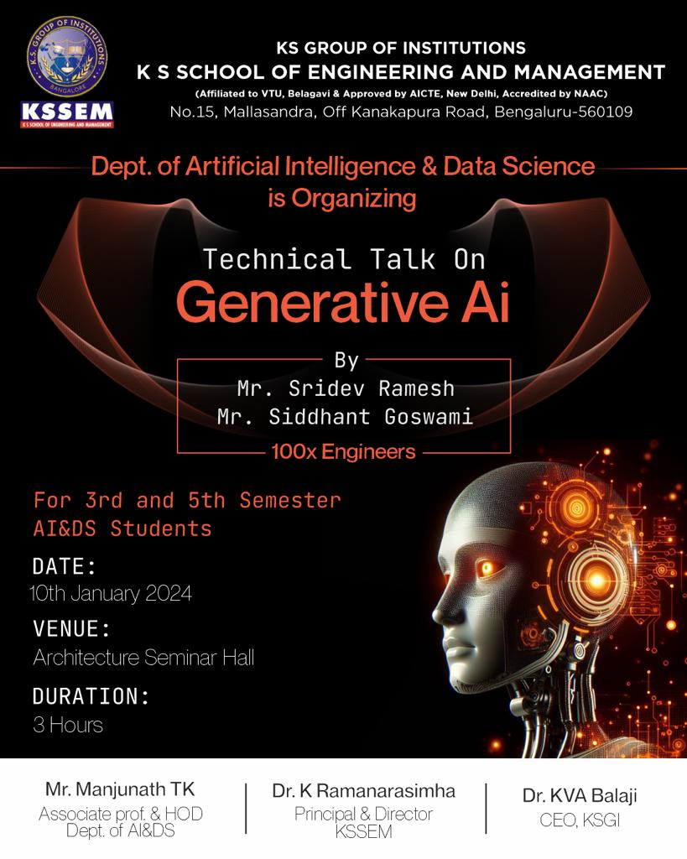

**Technical Talk on Generative Ai**

"Department of AI&DS organized technical talk on Generative AI by Mr. Sridev Ramesh and Mr. Siddhant Goswami(100x Engineers)"

2024-01-10

**Technical Talk on Unlocking the Secrets of Git and GitHub**

"Department of Artificial Intelligence organized workshop on "Unlocking the Secrets of Git and GitHub" for VI Semester students. It was conducted by Pygenic Arc."

2024-08-01

**Career Guidance**

"Department of Artificial Intelligence and Data Science, organized talk on career guidance by Mr. Narayan R, JB Portals Founder"

2023-12-08

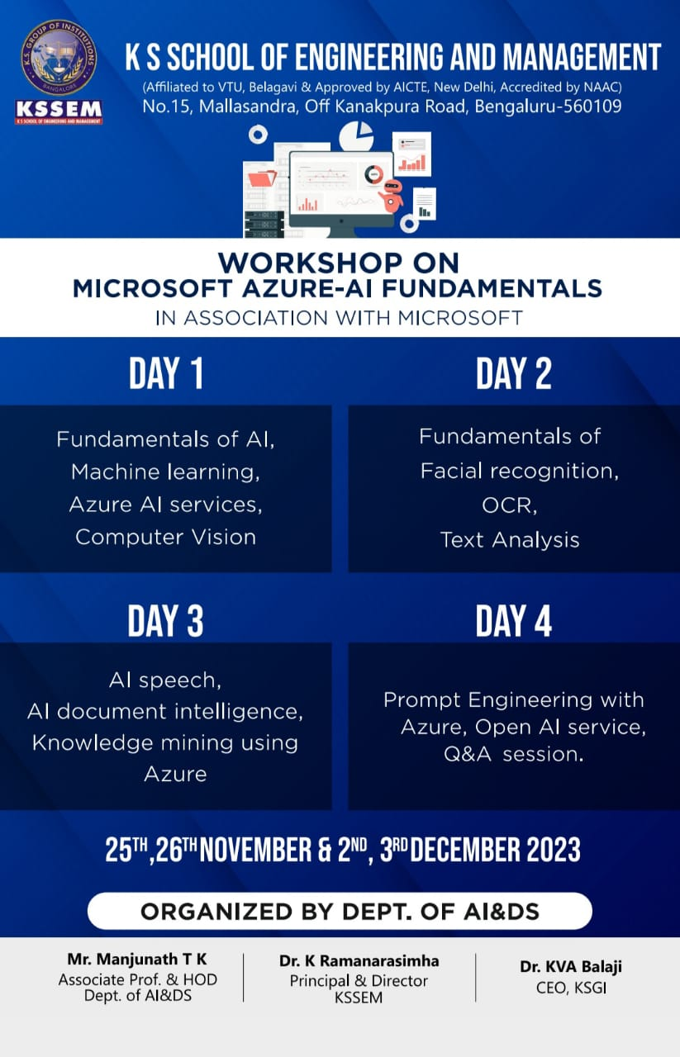

**Workshop on MS Azure AI Fundamentals**

"Internship on Microsoft Azure AI Fundamentals was conducted by IN_BIOT Pvt. Ltd., Microsoft associates. Resource Person: Mrs. Anjali, IN-BIOT Pvt. Ltd."

2023-11-25

**Orientation on Techsaksham Programme Edunet Foundation**

"Online Orientation program was conducted by team from Edunet Foundation, to promote the objectives and benefits of this program"

2023-11-28

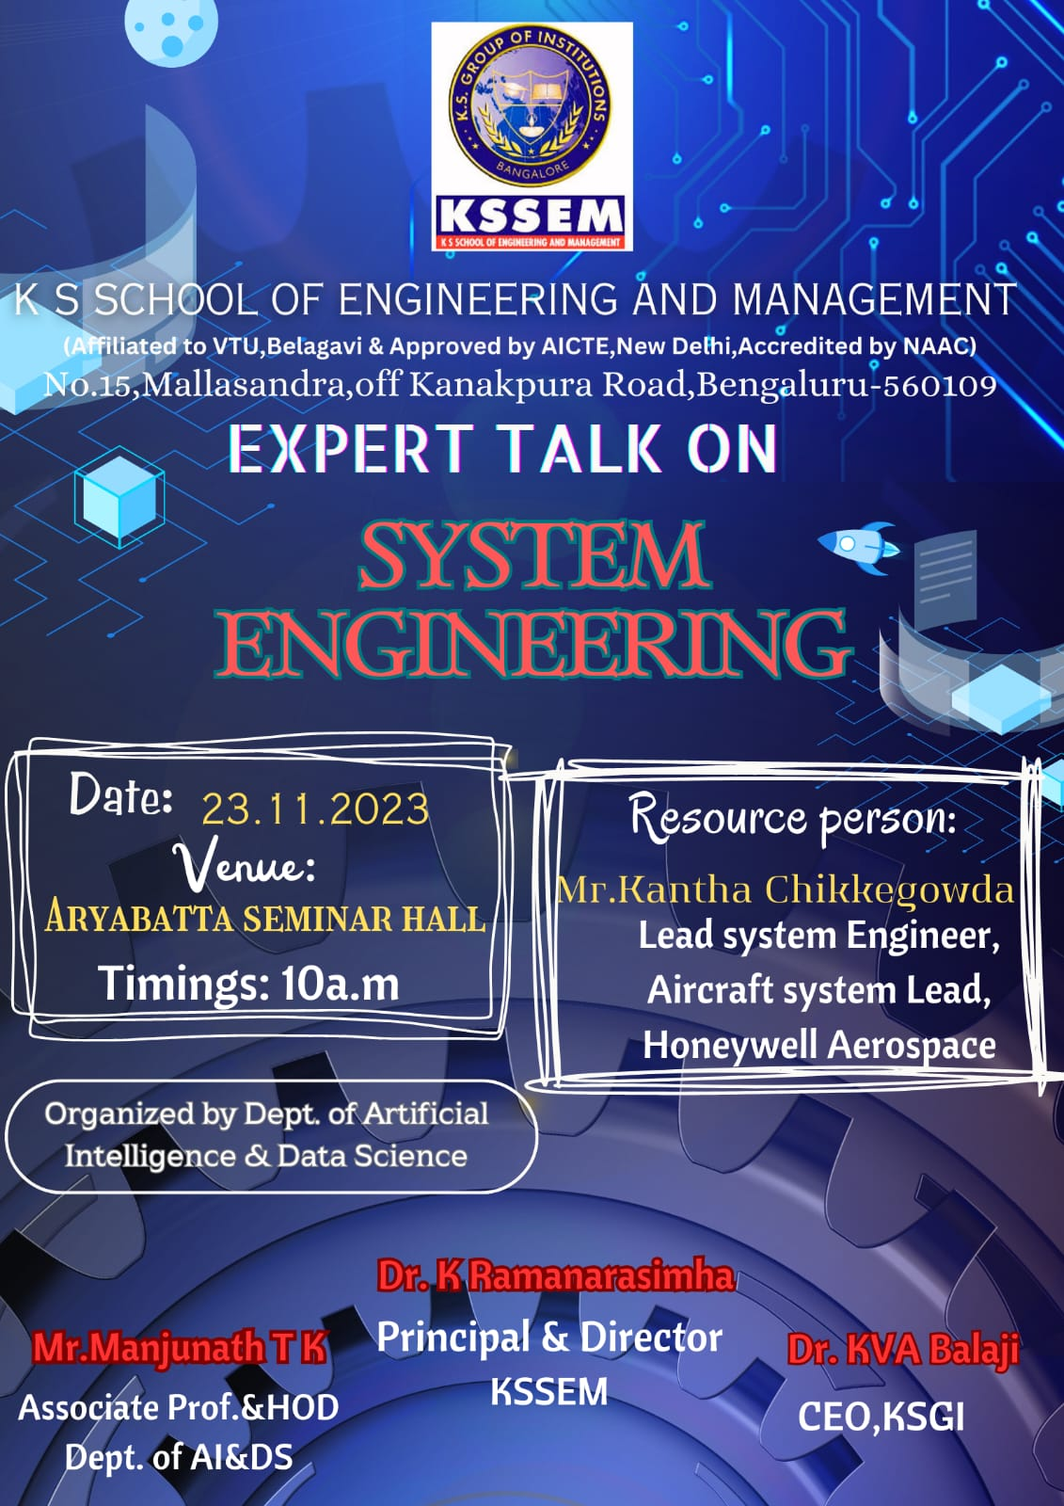

**Expert talk on System Engineering**

"Department of Artificial Intelligence and Data Science organized a talk on System engineering and it's significance and relevance were introduced to the students. Resource persons: Mr. Kantha Chikkegowda"

2023-11-23

**FOUNDATIONS OF DATA SCIENCE FOR MACHINE LEARNING**

"Department of AI and DS organized workshop for IV Semester, BE (AI & DS) students on Foundations of Data Science for machine learning conducted by INBIOT Pvt. Ltd."

2023-08-19

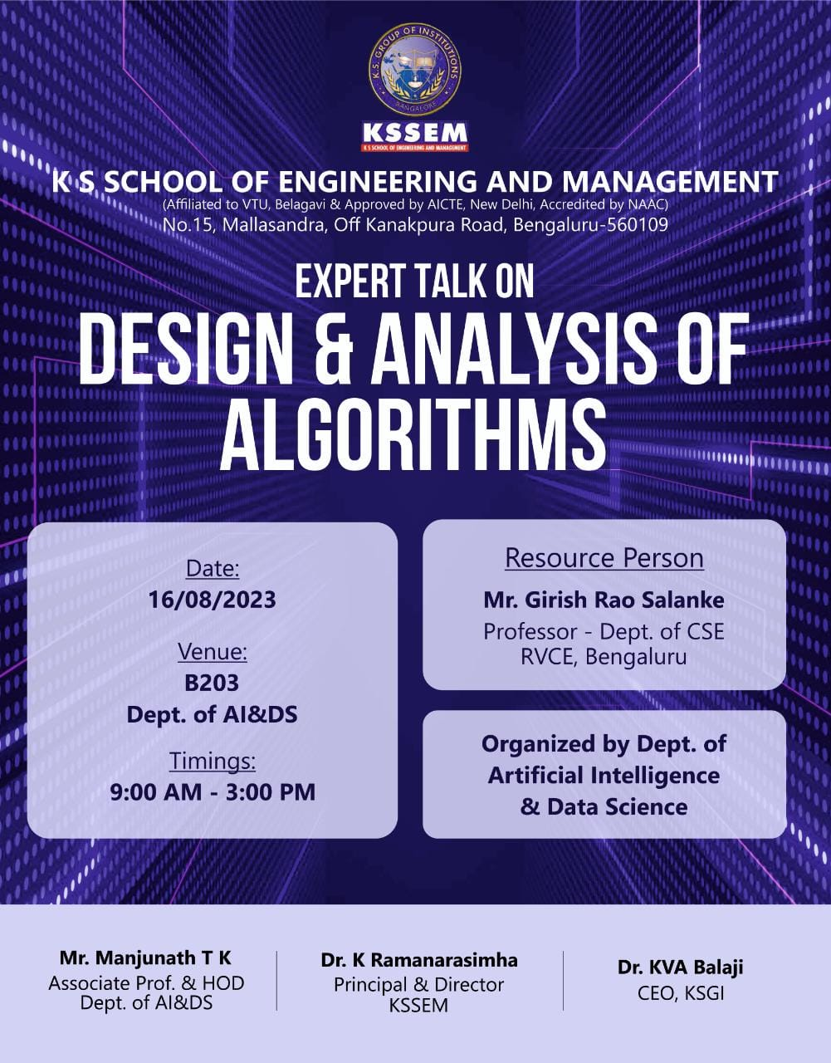

**Expert Talk - Design and Analysis of Algorithms**

"Department of AI & DS organized expert talk on DAA - Resource Person (Mr. Girish Rao Salanke"

2023-08-16

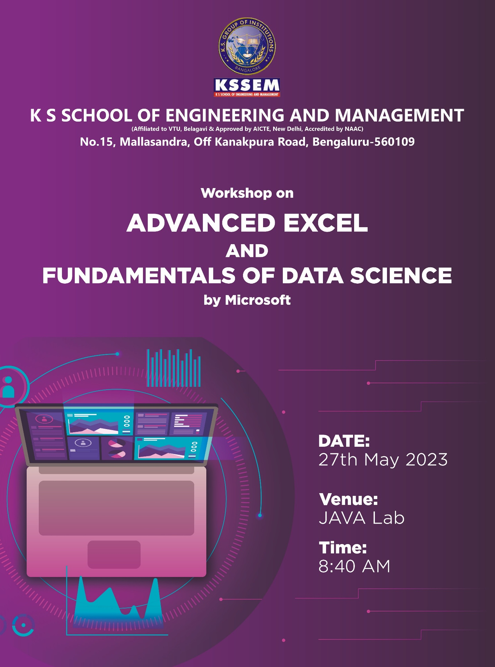

**Advanced Excel Workshop**

"Workshop on Advanced Excel and Fundamentals of Data Science was conducted on 27th May, 2023 by IN-BIOT Private Ltd (Microsoft Associate)."

2023-05-27

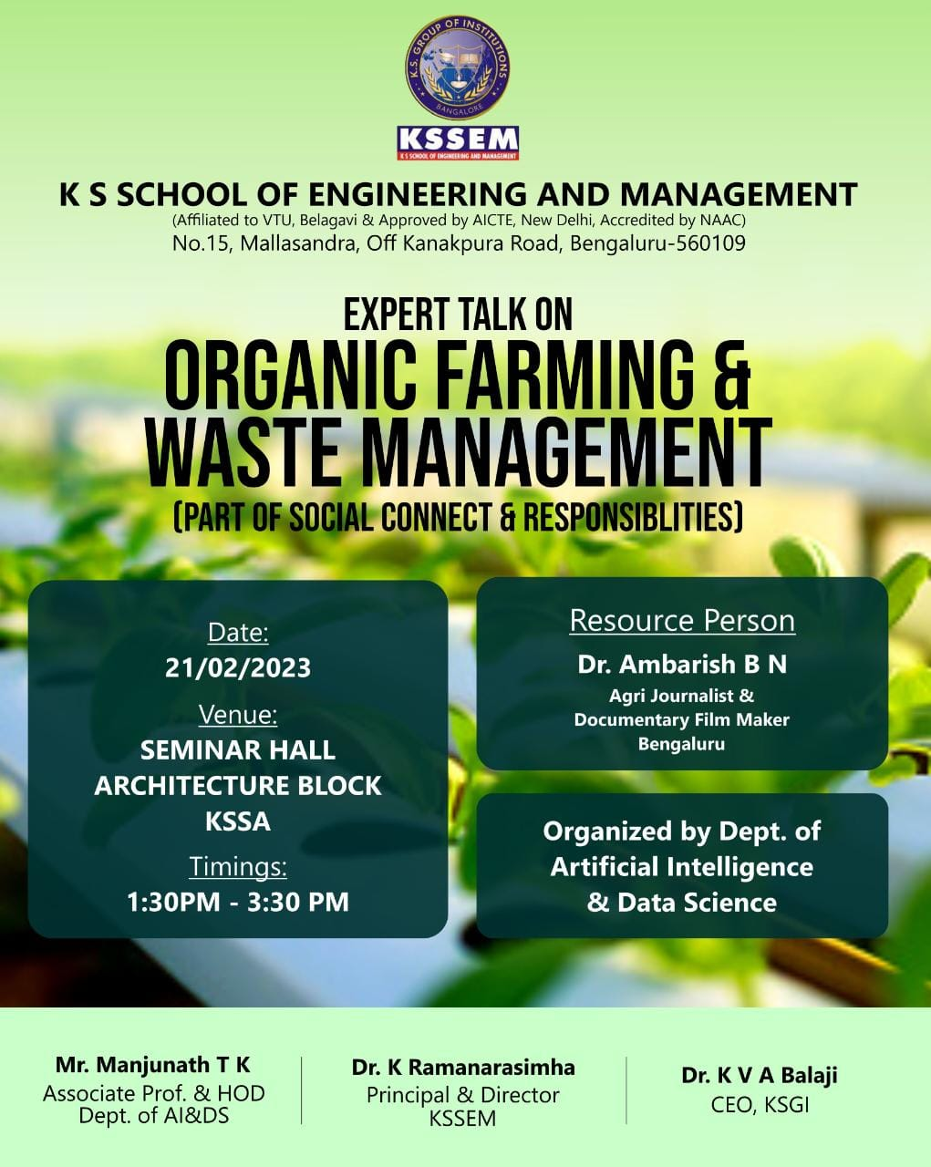

**Expert Talk on Organic Farming and Waste Management**

"Department of AI & DS conducted Expert talk on Organic Farming and Waste Management as part of Social Connect and Responsibility"

2023-02-21

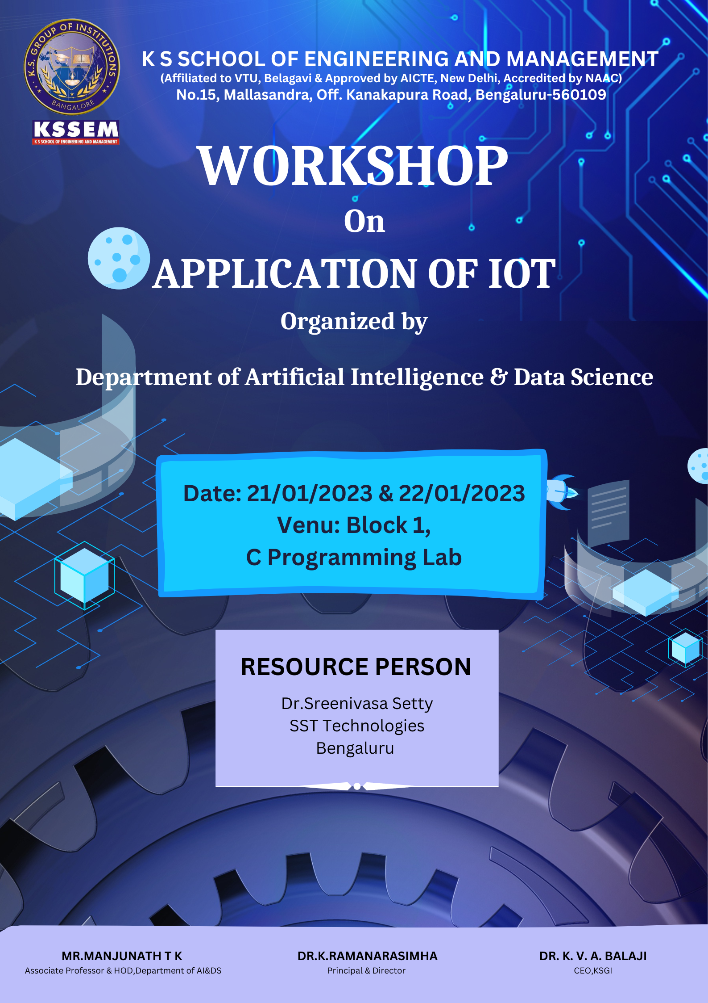

**IOT Workshop**

"Workshop impart knowledge in various cutting edge and emerging technologies. One such technology being IOT.The resource person was Dr. Srinivas Setty, who vast experience and knowledge in the field of IOT. "

2023-01-21

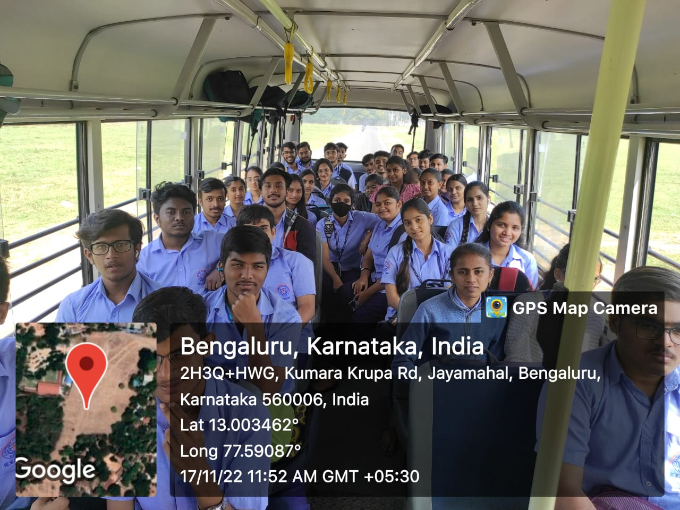

**BangaloreTechSummit**

"25 th edition of Bengaluru Technology summit is India's flagship technology event and Asia's largest tech summit. It was held on 17/11/2022. The event fostered international engagements and discussions across domains including FinTech, EdTech, Semiconductors, and Biotechnology, among others, in the country. "

2022-11-17

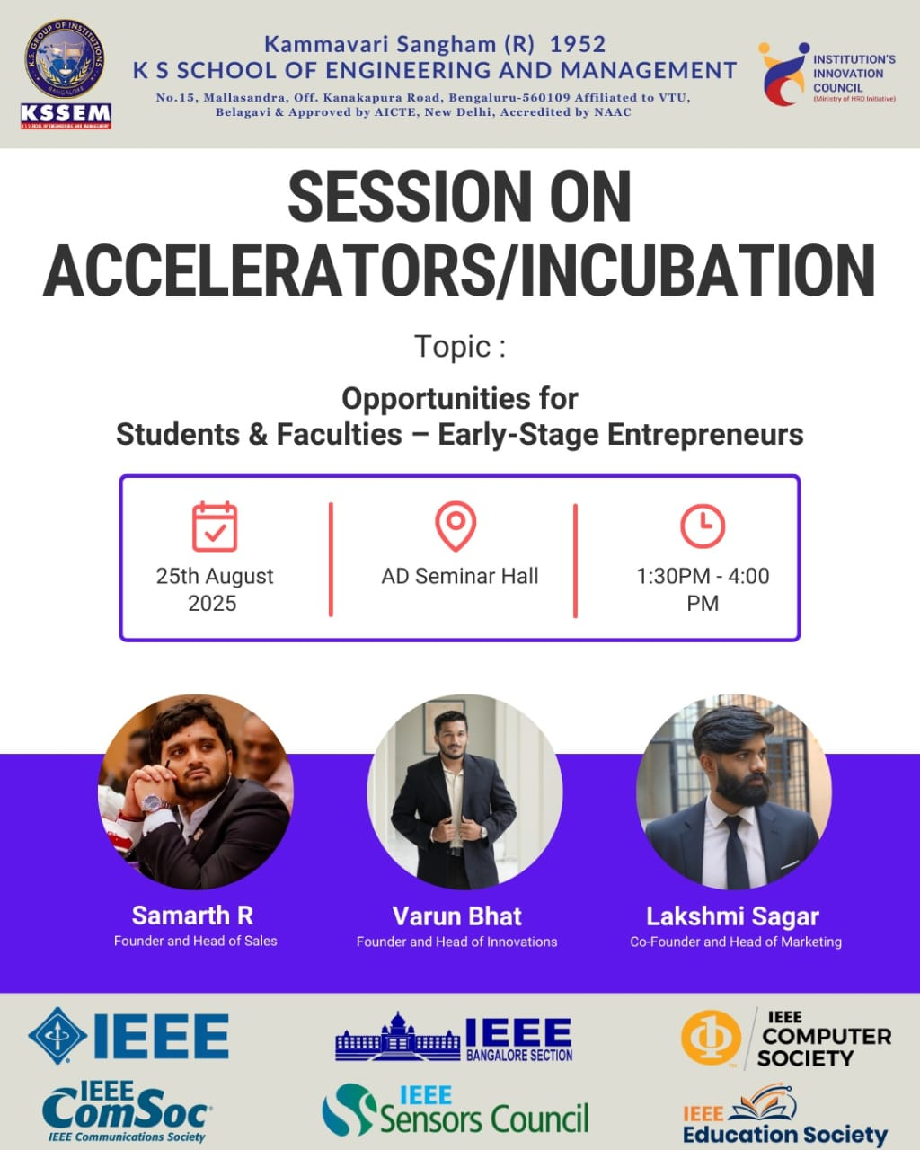

**session on accelerator and incubation**

"An accelerator and incubation session provides guidance, mentorship, and resources to support startups in transforming innovative ideas into scalable businesses. It focuses on nurturing entrepreneurship through funding, networking, and expert support."

2025-08-25

**EXPERT TALK ON OS DEMYSTIFIED FROM KERNEL TO INTERFACE**

"The Departments of AI & DS hosted talk on "OS Demystified from kernel to user interface" to provide students with information so they could ace interviews. "

2024-02-04

**E-resources**

A large number of Electronic Resources are available for all the subjects.

1st year C- Certification link- [[view here]](https://data-flair.training/courses/free-c-programming-course-hindi/)

1st year Python- Certification link [[view here]](https://data-flair.training/courses/python-course/)

1st year DSA- Certification link [[view here]](https://data-flair.training/courses/data-structures-and-algorithms/)

2 nd year Java-certification link [[view here]](https://data-flair.training/courses/free-java-course-hindi/)

2 nd year web-development-certification link [[view here]](https://data-flair.training/courses/free-web-development-course-hindi/)

2 nd year SQL-certification link [[view here]](https://data-flair.training/courses/free-sql-course-hindi/)

3 rd year Matplotlib-certification link [[view here]](https://data-flair.training/courses/free-matplotlib-course-hindi/)

3 rd year NumPy-certification link [[view here]](https://data-flair.training/courses/free-numpy-course-hindi/)

3 rd year OpenCV-certification link [[view here]](https://data-flair.training/courses/free-opencv-computer-vision-course-hindi/)

3 rd year Pandas-certification link [[view here]](https://data-flair.training/courses/free-python-pandas-course-hindi/)

4 th year Big Data-certification link [[view here]](https://data-flair.training/courses/free-big-data-hadoop-course/)

4 th year Apache Spark-certification link [[view here]](https://data-flair.training/courses/free-spark-scala-course/)

4 th year Kafka-certification link [[view here]](https://data-flair.training/courses/free-kafka-course/)

3rd year Machine Learning-certification link [[view here]](https://data-flair.training/courses/machine-learning-course-hindi/)

4th year Apache Flink certification link [[view here]](https://data-flair.training/courses/free-apache-flink-course/)

VTU resources [[view here]](https://kssem.edu.in/about_library#e_resources)

**Project Exhibition**

Project Presentation is organized to evaluate the projects by experts from Academic Institutions and/Industry. The students demonstrate the projects to the jury. The evaluation is done and 2 prizes are awarded for the best projects.

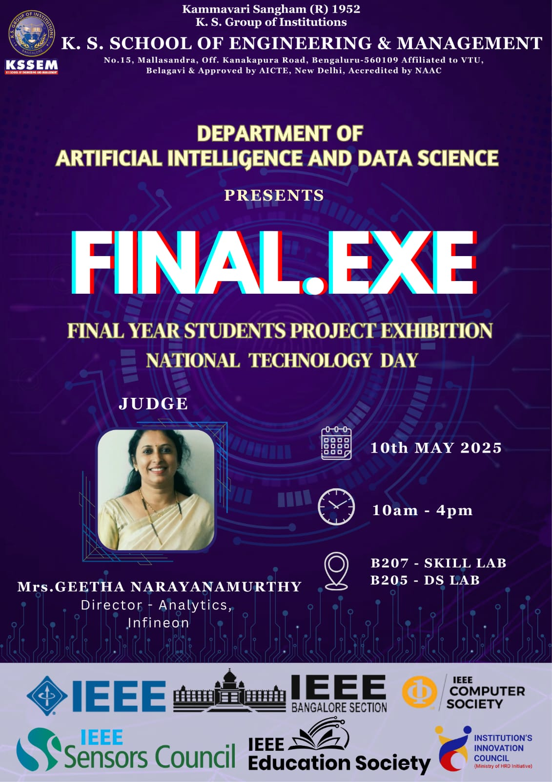

**MOUs Signed**

This Memorandum of Understanding (MoU) establishes the general terms and modalities for collaboration between the industry and K.S. School of Engineering and Management (KSSEM). The purpose of this partnership is to enhance knowledge sharing and foster meaningful interactions among industry experts, scientists, research scholars, and faculty members. Through this collaboration, both parties aim to jointly organize conferences, workshops, seminars, and hackathons, thereby promoting a culture of innovation and continuous learning. The MoU also seeks to provide KSSEM students with valuable industry exposure by facilitating internships, industrial training, and guided project work, all under mutual agreement. Additionally, the industry will be granted access to institutional infrastructure such as the library, internet, and computational facilities to support collaborative initiatives and research activities.

* Data Flair [[view here]](https://kssem.edu.in/images/1755836338404_image.pdf)
* Edunet_TechSaksham [[view here]](https://kssem.edu.in/images/1755836251712_image.pdf)
* Exceler [[view here]](https://kssem.edu.in/images/1751624461523_image.pdf)
* Pygenicarc [[view here]](https://kssem.edu.in/images/1751624531959_image.pdf)
* Microsoft [[view here]](https://kssem.edu.in/images/1751624609178_image.pdf)
* Mevi Technologies [[view here]](https://kssem.edu.in/images/1751970875298_image.pdf)
* edunet_IBM [[view here]](https://kssem.edu.in/images/1756368102517_image.pdf)